AI-Driven Intrusion Detection and Threat Mitigation System for Secure Networks



Project ID: Fall-2025-104

Session: BSCS Fall 2022 to 2026

Project Advisor: Dr. Nadeem Iqbal

Submitted By

Muhammad Usman Tariq |  | 70139691
Muhammad Mousa Khan | 70140245

Department of Computer Science & IT
The University of Lahore
Lahore, Pakistan

Declaration

We have read the project guidelines, and we understand the meaning of academic dishonesty, in particular plagiarism and collusion. We hereby declare that the work we submitted for our final year project, entitled "AI-Driven Intrusion Detection and Threat Mitigation System for Secure Networks," is original work and has not been printed, published or submitted before as final year project, research work, publication or any other documentation.

Group Member 1 Name: Muhammad Usman Tariq
SAP No: 70139691

Signature: …………………………

Group Member 2 Name: Muhammad Mousa Khan
SAP No: 70140245

Signature: …………………………

Statement of Submission

This is to certify that Muhammad Usman Tariq (70139691) and Muhammad Mousa Khan (70140245) have successfully submitted their final year project named "AI-Driven Intrusion Detection and Threat Mitigation System for Secure Networks" to the Department of Computer Science & IT, The University of Lahore, Lahore, Pakistan, in partial fulfillment of the requirements for the degree of Bachelor of Science in Computer Science.

Supervisor Name: Dr. Nadeem Iqbal

Signature: …………………………
Date: Jun. 1, 2026

Dedication

This project is dedicated to our families, whose constant support and encouragement made this work possible, and to our teachers, who taught us that the greatest form of knowledge is that which is pursued for its own sake and that even the most challenging tasks can be accomplished when approached one step at a time.

Acknowledgement

We truly acknowledge the cooperation and help provided by Dr. Nadeem Iqbal, professor at The University of Lahore. He has been a constant source of guidance throughout the course of this project. We would also like to thank the faculty members of the Department of Computer Science & IT, The University of Lahore, for their valuable suggestions and support. We are also thankful to our friends and families whose silent support helped us complete this project.

Date:
Jun. 1, 2026

Abstract

With the increasing dependence on computer networks, security threats have become more frequent and sophisticated. Traditional intrusion detection systems often rely on static rules or predefined signatures, which limits their ability to detect new and evolving attacks.
This project presents an AI-driven intrusion detection and threat mitigation system for secure networks, designed to monitor and analyze network traffic on a single standalone host. The system captures live network traffic (or replays dataset-based traffic), preprocesses it into per-flow feature vectors, and applies machine learning to classify each flow as benign or malicious and to identify the attack family of malicious flows. Upon detecting suspicious activity, the system generates alerts, assigns a severity level, logs detailed event information, and persists all records in a local database.
Building on a detection core developed and defended in an earlier phase, the system adds two-role access control with an append-only audit trail, validation against real attacks in an isolated laboratory, a human-in-the-loop mitigation workflow that blocks attacker addresses at the host firewall after administrator approval, and an advisory AI incident-report capability. The system operates as a standalone desktop application with no cloud dependency, making it suitable for academic environments and small-scale organizations. Experimental results demonstrate that the system effectively identifies malicious traffic while providing meaningful alerts, an auditable record of actions, and a controlled mitigation response.

Area of the Project

This project falls within the domain of artificial intelligence and machine learning, with a primary focus on cybersecurity and network security. It specifically addresses intrusion detection by applying machine learning to analyze network traffic and identify malicious activity, and extends this with access control, auditing, and controlled threat mitigation, making it relevant to both academic research and practical security monitoring.

Technologies used

The system is implemented in Python. Machine learning is built with Scikit-learn, packet capture uses Scapy with the Npcap driver, the backend is built with FastAPI served by Uvicorn, and the security operations dashboard is built with Streamlit and wrapped as a desktop application using pywebview. SQLite provides local, file-based storage for traffic flows, detections, alerts, users, sessions, the audit log, and the mitigation workflow. Firewall mitigation is enforced through the Windows netsh interface, and an optional local language model served by Ollama generates advisory incident reports.

List of Figures

Figure 3.1 — Use Case Diagram: Capture network traffic 22
Figure 3.2 — Use Case Diagram: Preprocess network traffic 24
Figure 3.3 — Use Case Diagram: Classify network traffic 25
Figure 3.4 — Use Case Diagram: Generate alerts, logs, and mitigation information 26
Figure 3.5 — Use Case Diagram: View alerts, logs, and mitigation information 28
Figure 3.6 — Use Case Diagram: Authenticate 29
Figure 3.7 — Use Case Diagram: Manage users 30
Figure 3.8 — Use Case Diagram: Control traffic source 31
Figure 3.9 — Use Case Diagram: Request mitigation 32
Figure 3.10 — Use Case Diagram: Approve / deny and enforce block 34
Figure 3.11 — Use Case Diagram: Unblock IP 35
Figure 3.12 — Use Case Diagram: View audit log 36
Figure 3.13 — Use Case Diagram: Generate AI incident report 37
Figure 4.1 Architecture Diagram 40
Figure 4.2 ERD 41
Figure 4.3.1 Level 0 DFD 42
Figure 4.3.2 Level 1 DFD 43
Figure 4.4 Class Diagram 44
Figure 4.5 Aggregated Activity Diagram 45
Figure 4.5.1 Activity Diagram capture network traffic 45
Figure 4.5.2 Activity Diagram preprocess network traffic 46
Figure 4.5.3 Activity Diagram classify network traffic 46
Figure 4.5.4 Activity Diagram generate alerts, logs, and mitigation information 46
Figure 4.5.5 Activity Diagram view alerts, logs, and mitigation information 47
Figure 4.5.6 Activity Diagram mitigation workflow 47
Figure 4.5.7 Activity Diagram generate AI incident report 47
Figure 4.6 Aggregated Sequence Diagram 48
Figure 4.6.1 Sequence Diagram Capture network traffic 49
Figure 4.6.2 Sequence Diagram preprocess network traffic 50
Figure 4.6.3 Sequence Diagram classify network traffic 51
Figure 4.6.4 Sequence Diagram Generate alerts, logs, and mitigation information 52
Figure 4.6.5 Sequence Diagram view alerts, logs, and mitigation information 53
Figure 4.6.6 Sequence Diagram authenticate 54
Figure 4.6.7 Sequence Diagram mitigation workflow 55
Figure 4.6.8 Sequence Diagram generate AI incident report 55
Figure 4.7 Collaboration Diagram 56
Figure 4.8 State Transition Diagram 57
Figure 4.9 Component Diagram 58
Figure 4.10 Deployment Diagram 59
Figure 8.1 — Application starting / launcher screen 87
Figure 8.2 — Login screen 88
Figure 8.3 — Main SOC dashboard overview 89
Figure 8.4 — Sidebar traffic source controls (capture / replay) 90
Figure 8.5 — Recent alerts table with attack rows highlighted 91
Figure 8.6 — Request Block panel 92
Figure 8.7 — Mitigation page: pending requests and active blocks 93
Figure 8.8 — Users management page 94
Figure 8.9 — Audit log page 95
Figure 8.10 — AI incident report panel 96
Figure 8.11 — Logout control 97

List of Tables

Table 2.1 Functional Requirement — Capture network traffic 10
Table 2.2 Functional Requirement — Preprocess and extract features 11
Table 2.3 Functional Requirement — Classify network traffic 12
Table 2.4 Functional Requirement — Generate alerts, logs, and mitigation information 13
Table 2.5 Functional Requirement — View alerts, logs, and mitigation information 14
Table 2.6 Functional Requirement — User login and logout 15
Table 2.7 Functional Requirement — Role-based access control 16
Table 2.8 Functional Requirement — User management 16
Table 2.9 Functional Requirement — Audit logging 17
Table 2.10 Functional Requirement — Request mitigation 17
Table 2.11 Functional Requirement — Approve/deny and enforce block 18
Table 2.12 Functional Requirement — Unblock IP 19
Table 2.13 Functional Requirement — Generate AI incident report 19
Table 5.1 Positive Test Case 60
Table 5.2 Negative Test Case 61
Table 5.3 Positive Test Case 62
Table 5.4 Positive Test Case 63
Table 5.5 Negative Test Case 63
Table 5.6 Positive Test Case 64
Table 5.7 Positive Test Case 65
Table 5.8 Positive Test Case 66
Table 5.9 Negative Test Case 67
Table 5.10 Positive Test Case 67
Table 5.11 Negative Test Case 68
Table 5.12 Positive Test Case 69
Table 5.13 Negative Test Case 69
Table 5.14 Positive Test Case 70
Table 5.15 Positive Test Case 71
Table 5.16 Negative Test Case 71
Table 5.17 Positive Test Case 72
Table 5.18 Negative Test Case 73
Table 5.19 Positive Test Case 73
Table 5.20 Negative Test Case 74
Table 5.21 Positive Test Case 74
Table 5.22 Negative Test Case 75
Table 5.23 Equivalence Partitioning — Valid and Invalid Classes 76
Table 5.24 Highest Cyclomatic Complexity Functions 79

Table of Contents

Declaration i
Statement of Submission ii
Dedication iii
Acknowledgement iv
Abstract v
List of Figures vii
List of Tables ix
Chapter 1: Introduction to the Problem 1
1.1 Introduction 1
1.2 Purpose 1
1.3 Objective 2
1.4 Existing Solution 2
1.5 Proposed Solution 3
Chapter 2: Software Requirement Specification 4
2.1 Introduction 4
2.1.1 Purpose 4
2.1.2 Scope 4
2.1.3 Definitions, acronyms, and abbreviations 5
2.2 Overall description 5
2.2.1 Product perspective 5
2.2.2 Product functions 7
2.2.3 User characteristics 8
2.2.4 Constraints 8
2.2.5 Assumptions and dependencies 9
2.2.6 Apportioning of requirements 9
2.3 Specific requirements 9
2.3.1 Functional Requirement 10
2.3.2 Non-functional Requirements 20
Chapter 3: Use Case Analysis 22
3.1 Use case — Capture network traffic 22
3.1.1 Use case detail 23
3.2 Use case — Preprocess network traffic 24
3.2.1 Use case detail 24
3.3 Use case — Classify network traffic 25
3.3.1 Use case detail 25
3.4 Use case — Generate alerts, logs, and mitigation information 26
3.4.1 Use case detail 26
3.5 Use case — View alerts, logs, and mitigation information 27
3.5.1 Use case detail 28
3.6 Use case — Authenticate (login / logout) 28
3.6.1 Use case detail 29
3.7 Use Case — Manage users 30
3.7.1 Use case detail 30
3.8 Use Case — Control traffic source 31
3.8.1 Use case detail 31
3.9 Use Case — Request mitigation 32
3.9.1 Use case detail 33
3.10 Use Case — Approve / deny and enforce block 34
3.10.1 Use case detail 34
3.11 Use Case — Unblock IP 35
3.11.1 Use case detail 35
3.12 Use Case — View audit log 36
3.12.1 Use case detail 36
3.13 Use Case — Generate AI incident report 37
3.13.1 Use case detail 38
Chapter 4: Design 39
4.1 Architecture Diagram 39
4.2 ERD with data dictionary 40
4.3 Data Flow diagram 42
4.3.1 The level 0 42
4.3.2 The level 1 42
4.4 Class Diagram 43
4.5 Activity Diagram 45
4.6 Sequence Diagram 48
4.7 Collaboration Diagram 56
4.8 State Transition Diagram 57
4.9 Component Diagram 57
4.10 Deployment Diagram 59
Chapter 5: Testing 60
5.1 Test Case Specifications 60
5.2 Black Box Test Cases 75
5.2.1 Equivalence Partitions (EP) 75
5.2.2 Boundary Value Analysis 76
5.2.3 Decision Table Testing 76
5.2.4 State transition Testing 76
5.2.5 Use Case Testing 77
5.3 White Box Test Cases 77
5.3.1 Cyclomatic complexity 77
5.4 Performance testing 79
5.5 Stress Testing 79
5.6 System Testing 80
5.7 Regression Testing 80
Final Regression Tests 80
Regression Tests 80
5.7.1 Selecting Regression Tests 80
5.7.2 Regression Testing Steps 81
Chapter 6: Tools and Techniques 82
6.1 Languages 82
6.2 Applications and Tools 82
6.3 Libraries and Extensions 83
6.4 Techniques 83
Chapter 7: Summary and Conclusion 85
7.1 Summary 85
7.2 Conclusion 86
Chapter 8: User Manual 87
8.1 Starting the System 87
8.2 Login 88
8.3 Dashboard Overview 88
8.4 Starting Traffic Capture or Replay 90
8.5 Real-Time Alert Monitoring 91
8.6 Requesting a Block (Analyst) 91
8.7 Approving a Block and Enforcing Mitigation (Administrator) 92
8.8 Managing Users (Administrator) 93
8.9 Viewing the Audit Log (Administrator) 94
8.10 Generating an AI Incident Report 95
8.11 Logging Out 96
Chapter 9: Lessons Learnt and Future Work 98
9.1 Lessons Learnt 98
9.2 Future Work 99
References 100
Appendix 101

Chapter 1: Introduction to the Problem

Introduction
Computer networks have expanded fast, and so has the attack surface that comes with them. Denial-of-service floods, port scans, brute-force login attempts, web application attacks — these are no longer edge cases. They're routine. Firewalls and static rule sets can block known threats, but they have no good answer for traffic that doesn't match any existing signature.
Network-based intrusion detection systems (NIDS) sit in between: they watch live traffic and flag behavior that looks wrong. The problem is most of them stop there. Detection fires, an alert goes somewhere, and then what? Without a defined path from detection to response, operators are left making judgment calls with incomplete information and no tooling to back them up. And if the system relies entirely on predefined rules, anything genuinely new just passes through.
This project builds an AI-driven NIDS that addresses both gaps. The system captures network traffic in near real time, classifies each flow as benign or malicious, and — for malicious flows — identifies the specific attack family. From there it handles alerting, logging, and severity scoring automatically, and gives the operator a firewall-based mitigation workflow to act on rather than just an alert to stare at. The whole thing runs on a single Windows host with no cloud dependency. A two-role security operations dashboard handles monitoring and response, separating analyst and admin access.

Purpose

This project aims to build a network intrusion detection system that uses machine learning to catch malicious traffic and give operators a practical way to act on what it finds. Unlike rule-based detection, which can only flag what it already knows, the ML model generalizes — if an attack shares statistical patterns with something in the training data, the system can still catch it even without a matching signature.
Detection alone isn't enough, though. Once a threat is identified, the system assigns it a severity level, logs it, and surfaces an alert through a dashboard. From there, the operator can review the flagged flow and, if they agree with the assessment, block the source IP at the host firewall. Every enforcement action goes through that human review step — nothing gets blocked automatically. That keeps a person in control while still cutting down the time between detection and response.

Objective

The main objectives of this project are:
- To study existing intrusion detection and threat mitigation techniques used in modern network security systems.
- To design and develop an AI-driven, network-based intrusion detection system that operates on a single, standalone host.
- To implement machine learning models that classify network traffic as benign or malicious and further categorize malicious traffic into attack families.
- To assess and categorize detected threats based on their severity levels.
- To generate alerts, logs, and mitigation-related information for detected intrusions, persisted with referential integrity.
- To generate, on demand, a plain-language incident report for a detected attack to assist the operator in understanding and documenting the event.
- To validate detection capability against real, live attacks generated in a controlled lab environment, in addition to dataset-based replay.
- To provide controlled, role-based access to the system through two operator roles (administrator and analyst) with an append-only audit trail of privileged actions.
- To provide a human-in-the-loop mitigation capability that allows an operator to block and unblock attacker IP addresses at the host firewall through a reviewed, audited process.
- To provide a user-friendly security operations dashboard for monitoring network activity and security events.
- To evaluate the system's performance using standard intrusion detection and classification metrics.

Existing Solution
Intrusion detection systems generally fall into two categories: signature-based and anomaly-based. Signature-based systems like Snort and Suricata work by matching traffic against known rules — if the traffic fits a pattern, it gets flagged. That works well for known threats, but it has a hard ceiling: every attack needs an explicit rule, and anything without a matching signature gets through.
Anomaly-based systems take a different approach, looking for deviations from normal behavior rather than checking against a fixed list. In practice, most deployed solutions still lean heavily on the signature side, and almost all of them treat detection as the end of the job. What happens after an alert fires is usually left to the operator, with no structured workflow to support the response. [1]
Cost and complexity make things worse. Most capable NIDS tools are built for enterprise environments — they assume dedicated hardware, cloud connectivity, or expensive licensing. Small organizations and academic setups rarely have any of that. A system that runs locally, costs nothing to deploy, and actually guides an operator from detection through to a mitigation decision doesn't really exist as an out-of-the-box option.

Proposed Solution

The proposed solution is an AI-driven intrusion detection and threat mitigation system designed to monitor and analyze network traffic on a single Windows host. The system converts network traffic into per-flow feature vectors and classifies them using trained Random Forest models in two stages: a binary stage that distinguishes benign from malicious traffic, followed by a multi-class stage that identifies the attack family for traffic flagged as malicious.
Upon detecting malicious activity, the system generates an alert, assigns a severity level, stores attack-type-specific response guidance, and persists the full record (traffic flow, detection result, alert, and mitigation record) in a local database. Detections are surfaced on a security operations dashboard that supports two roles: an analyst who can monitor activity and request that an attacker IP be blocked, and an administrator who reviews and approves or denies those requests. Approved blocks are enforced at the host firewall using the Windows netsh interface, and a two-person rule prevents an operator from approving their own request. Every privileged action is recorded in an append-only audit log. In addition, the operator can generate an on-demand, plain-language incident report for any detected attack; this report is produced locally by a small language model and is advisory only, never affecting detection or enforcement. [2]
Unlike traditional signature-only systems, the proposed solution uses machine learning that generalizes to attacks sharing statistical features with its training distribution, and unlike detect-only tools it provides an integrated, reviewed mitigation path. The system operates fully offline with no cloud dependency, keeping it suitable for academic and small-scale deployment environments where a local, controlled, and auditable tool is preferred.

Chapter 2: Software Requirement Specification

Introduction
This Software Requirements Specification (SRS) document defines the functional and non-functional requirements of the AI-driven intrusion detection and threat mitigation system for secure networks. It serves as a formal reference for system design, development, implementation, and evaluation throughout the project lifecycle.
The intended audience of this document includes project supervisors, evaluators, developers, and academic reviewers who require a clear and structured understanding of the system's behavior, scope, constraints, and operational requirements.

Purpose

The purpose of this SRS is to provide a detailed and well-structured description of the requirements of the intrusion detection and threat mitigation system. This document ensures that all system functionalities, constraints, and quality attributes are clearly defined, thereby reducing ambiguity, improving design consistency, and supporting verification of the implemented system against its requirements

Scope
The system, titled "AI-Driven Intrusion Detection and Threat Mitigation System for Secure Networks," is a network-based security system that monitors and analyzes network traffic to detect malicious activity and supports a controlled threat-mitigation response. It operates entirely on a single Windows host with no cloud dependency.
The system captures network traffic (either from a live network interface or from a dataset-based replay simulator), aggregates packets into per-flow feature vectors, and applies trained machine learning models to classify each flow as benign or malicious and to identify the attack family of malicious flows. Upon detecting malicious activity, the system generates alerts, assigns a severity level, maintains detailed logs, and persists all detections in a local database. Detections and security events are presented through a security operations (SOC) dashboard delivered as a native desktop application.
The system supports two operator roles — administrator and analyst — with role-based access control and an append-only audit trail of all privileged actions. For threat mitigation, the system provides a human-in-the-loop workflow: an analyst may request that an attacker IP address be blocked, and an administrator reviews and approves or denies the request. Approved blocks are enforced at the host firewall using the Windows netsh interface, and a two-person rule prevents an operator from approving their own request.
The system does not perform automatic enforcement (no firewall changes without human approval) and does not perform network-level blocking at routers or switches; mitigation is host-level only. The system is intended for academic, research, and small-scale deployment environments.

Definitions, acronyms, and abbreviations
- IDS — Intrusion Detection System
- NIDS — Network-based Intrusion Detection System
- AI — Artificial Intelligence
- ML — Machine Learning
- RF — Random Forest (the machine learning algorithm used)
- SOC — Security Operations Center
- GUI — Graphical User Interface
- API — Application Programming Interface
- REST — Representational State Transfer (the API style used)
- RBAC — Role-Based Access Control
- CORS — Cross-Origin Resource Sharing
- NIC — Network Interface Card
- DoS / DDoS — Denial-of-Service / Distributed Denial-of-Service
- FR / NFR — Functional Requirement / Non-Functional Requirement
- SQLite — The local, file-based relational database used for persistence
- netsh — The Windows command-line utility used to apply host firewall rules

Overall description

Product perspective
The system is a standalone, desktop-based network intrusion detection and threat mitigation system. It operates independently without reliance on cloud infrastructure or external servers. Internally it is composed of a REST backend (FastAPI) that performs inference, persistence, and control, and a SOC dashboard (Streamlit) that provides the operator interface; the dashboard is wrapped in a native desktop window so that the user interacts with it as a desktop application rather than through a web browser. All services bind to the local loopback interface only. The system captures network traffic from a monitored interface (or replays dataset-based traffic), processes the data locally, applies trained machine learning models to detect malicious activity, and supports an audited, human-in-the-loop firewall mitigation response.
To further describe the product perspective, the system interfaces and operational characteristics are defined as follows:

System interfaces:
The system interfaces with the host operating system to capture live network traffic from available network interfaces and to apply firewall rules through the Windows netsh utility. Internally, the dashboard communicates with the backend over local HTTP (REST) on the loopback interface. The backend performs feature extraction, machine-learning classification, persistence, and the mitigation control workflow. The system does not modify or block traffic automatically; firewall changes occur only after explicit human approval.
User interfaces:
The system provides a graphical user interface delivered as a native desktop window that allows users to:
- Sign in and sign out (role-aware access)
- Start and stop traffic capture and select a network interface (administrator)
- Start and stop the dataset-based replay simulator (administrator)
- View real-time alerts with associated attack type and threat severity
- Request that an attacker IP be blocked (analyst and administrator)
- Approve, deny, or reverse (unblock) mitigation actions (administrator)
- Manage user accounts and view the audit log (administrator)
- Review historical intrusion logs and summary charts
The interface is designed to be simple and role-appropriate. Screenshots of the GUI are provided in the user manual section to demonstrate system usage and workflow.
Hardware interfaces:
The system requires access to a standard network interface card (Ethernet or wireless) on the host machine for live capture. No specialized hardware is required beyond a standard desktop or laptop system.
Software interfaces:
The system depends on the host operating system for network access and firewall control, and on a set of open-source Python libraries for its core functions: scikit-learn for classification, Scapy (with the Npcap driver on Windows) for packet capture, FastAPI/Uvicorn for the REST backend, Streamlit and Plotly for the dashboard, pywebview for the native window, and the SQLite library for local persistence and, optionally, a locally hosted language model service (Ollama) used solely to generate advisory incident reports. If this service is absent, all other functions are unaffected. The system does not rely on external applications or third-party online services during runtime.

Communications interfaces:
The system passively observes network traffic using standard protocols such as TCP, UDP, and ICMP; it does not initiate or alter monitored communications. Internally, the dashboard and backend communicate over local HTTP confined to the loopback interface, with cross-origin access pinned to the dashboard origin. Firewall enforcement is issued to the operating system through netsh.
Memory:
The system uses primary memory (RAM) for real-time traffic processing, feature extraction, and classification; the trained models occupy roughly 170 MB combined when loaded. Secondary storage holds the trained model files, the SQLite database, the rotating CSV alert log, and the firewall block ledger. Memory usage is constrained by the resources of the host machine.
Operations:
Normal operations include signing in, monitoring detections, starting and stopping capture or replay, requesting and approving mitigation actions, and reviewing alerts, logs, and the audit trail. Special operations include loading the trained models at startup, bootstrapping the first administrator account, and unblocking previously blocked IPs. Backup and recovery involve preserving and restoring the SQLite database file, the alert log, and the firewall block ledger from local storage.
Site adaptation requirements:
The system may require basic configuration depending on the deployment environment, such as selecting the appropriate network interface and running with administrator elevation for live capture and firewall mitigation. A lab-only environment override exists to permit blocking of private IP ranges during controlled testing; in normal operation the system blocks public IP addresses only. No complex site-specific initialization is required.

Product functions
The main functions of the system include:
- Capturing real-time network traffic and replaying dataset-based traffic for demonstration and testing
- Preprocessing and extracting per-flow features from traffic data
- Classifying network traffic using trained machine learning models (benign vs. malicious, and attack-family identification)
- Generating alerts, logs, severity assessments, and mitigation guidance for detected intrusions, persisted with referential integrity
- Authenticating users and enforcing role-based access control across two roles
- Recording an append-only audit log of all privileged actions
- Managing user accounts (administrator)
- Generating an on-demand, plain-language incident report for a detected attack using a local language model (advisory only)
- Providing a human-in-the-loop firewall mitigation workflow (request → approve/deny → block/unblock)
- Visualizing alerts, logs, statistics, and security events through a SOC dashboard

User characteristics
The system is operated through two roles:
- Administrator — full control: managing users, viewing the audit log, starting/stopping capture and replay, and approving, denying, or reversing mitigation actions. An administrator is expected to be comfortable operating Windows with administrator elevation and to understand the implications of firewall changes.
- Analyst — monitors the dashboard, interprets alerts, and requests that attacker IPs be blocked, but cannot approve those requests or manage users.
Intended users include students and researchers, network administrators in small organizations, and small-org IT users. Users are expected to have basic computer literacy; no advanced cybersecurity expertise is required to interpret alerts, severity indicators, and mitigation guidance. However, because live capture and firewall mitigation require running with administrator elevation, the practical floor for those functions is a user who is comfortable operating a Windows machine.

Constraints
The system is subject to the following constraints:
- The system runs on a single Windows host; live capture and firewall mitigation are Windows-specific (they depend on Npcap and netsh).
- Detection depends on the availability of network traffic and on the quality of the training data; classification accuracy is bounded by the CIC-IDS2017 dataset, which exhibits class imbalance for some attack families. [3]
- The binary detector is reliable on session-based attacks but does not detect single-packet scan or flood traffic, because such flows fall outside the trained flow distribution.
- The system operates fully offline, without cloud-based threat-intelligence updates.
- The system does not perform automatic enforcement or network-level traffic blocking; mitigation is host-level and requires human approval.
- The AI incident-report feature depends on a locally running language model service and is advisory only; it is not part of the detection or enforcement path.
- The dashboard uses a multi-page framework in which administrator pages are blocked at the server side for analysts rather than hidden from navigation.
These constraints keep the system suitable for academic and small-scale environments.

Assumptions and dependencies
The system assumes that:
- The monitored network interface is accessible, and (for live capture) the Npcap driver is installed and the application is running with administrator elevation.
- For firewall mitigation, the process is elevated and no kernel-mode security software is intercepting the firewall changes.
- The trained models are present in the models directory, and the CIC-IDS2017 dataset is available for any retraining.
- Users operate the system in a controlled or isolated test network, and authorization exists for any monitoring and blocking performed.
The system depends on open-source machine-learning libraries, the Scapy/Npcap packet-capture stack, the SQLite database library, and the Windows netsh firewall utility.

Apportioning of requirements
The following features are considered out of scope for the current version and are candidates for future releases: multi-machine or endpoint-agent deployment; detection of single-packet scan and flood traffic; optional automatic blocking on high-confidence detection; encrypted-traffic detection; cloud or threat-intelligence integration; a production-grade web UI; a model retraining pipeline with drift monitoring; PDF report export; and support for additional datasets. Advanced enforcement such as automatic intrusion prevention and network-level traffic blocking remains explicitly out of scope.

Specific requirements

This section describes the functional and non-functional requirements of the AI-driven intrusion detection and threat mitigation system in sufficient detail to support system design and implementation. The functional requirements specify the core operations performed by the system; the non-functional requirements describe its quality attributes and operational constraints. Together they provide a clear basis for development and for verifying that the implemented system satisfies the defined requirements.

Functional Requirement
The following functional requirements describe the functions and modules of the system. Requirements FR_01–FR_05 are carried forward from Phase 1; FR_06–FR_13 specify the access-control, auditing, and mitigation capabilities added in Phase 2. Closely related control actions (for example, starting and stopping capture or replay, login lockout, and viewing active blocks) are documented within the workflow of their parent requirement.

ID: | FR_01
Name: | Capture Network Traffic
Description | Input | Output | Requirements | Basic Work Flow
The system shall capture live network packets from a selected network interface and shall also support replaying dataset-based traffic for demonstration and testing; an administrator can start and stop both sources. | Selected network interface; replay parameters (rate, attack ratio) | Raw network flows forwarded for analysis | Active network interface, Npcap driver, administrator elevation (live capture); running API (replay) | Admin selects an interface and starts capture, or starts the replay simulator → packets/flows are collected in real time → flows are forwarded for preprocessing

Table 2.1 Functional Requirement — Capture network traffic

ID: | FR_02
Name: | Preprocess and extract features
Description | Input | Output | Requirements | Basic Work Flow
The system shall aggregate captured packets into per-flow records and extract the 50 features required for machine learning classification. | Raw network packets (live) or dataset records (CIC-IDS2017) | Processed 50-feature flow vectors | Feature extraction module | Packets are grouped by flow using a 5-tuple with an inactivity timeout → features are computed → the feature vector is prepared for classification

Table 2.2 Functional Requirement — Preprocess and extract features

ID: | FR_03
Name: | Classify network traffic
Description | Input | Output | Requirements | Basic Work Flow
The system shall classify each network flow as benign or malicious using a trained Random Forest model, and shall further identify the attack family of malicious flows using a second classifier. | Processed 50-feature flow vector | Classification label (benign/malicious), confidence score, and attack type for malicious flows | Trained machine learning models, classification threshold | System loads trained models at startup → receives a processed flow → the binary model decides benign or attack → if attack, the multi-class model identifies the family → result is returned

Table 2.3 Functional Requirement — Classify network traffic

ID: | FR_04
Name: | Generate alerts, logs, and mitigation information
Description | Input | Output | Requirements | Basic Work Flow
The system shall generate an alert when malicious activity is detected, assign a severity level, store attack-type-specific mitigation guidance, and persist the full detection record. | Classification result. | Alert, log entry, severity level, mitigation guidance, persisted database records | Trained classification model, persistence, logging mechanism | System identifies a malicious flow → assigns severity → records flow, detection, alert, and mitigation entry in a single transaction → writes a backup log entry → the alert becomes available on the dashboard

Table 2.4 Functional Requirement — Generate alerts, logs, and mitigation information

ID: | FR_05
Name: | View alerts, logs, and mitigation information
Description | Input | Output | Requirements | Basic Work Flow
The system shall allow authenticated users to view detected intrusion alerts, historical logs, severity details, and summary statistics through the SOC dashboard. | Stored alerts, log records, and statistics; active session. | Visual display of alerts, severity levels, charts, and summaries | Graphical user interface, valid session | User signs in → opens the dashboard → system retrieves stored alerts, logs, and statistics → information is displayed in tables and charts

Table 2.5 Functional Requirement — View alerts, logs, and mitigation information

ID: | FR_06
Name: | User login and logout
Description | Input | Output | Requirements | Basic Work Flow
The system shall authenticate users with a username and password, issue a session token on success, and revoke it on logout; repeated failed attempts shall trigger a temporary lockout. | Username and password | Session token and role on success; error or lockout on failure | User account store, password hashing | User submits credentials → system verifies them against the stored hash → on success it issues a session token and records the login; after repeated failures it temporarily locks the account

Table 2.6 Functional Requirement — User login and logout

ID: | FR_07
Name: | Role-based access control
Description | Input | Output | Requirements | Basic Work Flow
The system shall enforce a two-role permission model (administrator and analyst), allowing each action only for the roles permitted to perform it. | Session token and the requested action/permission | Action allowed, or denied (unauthorized/forbidden) | Valid session, permission matrix | User requests a protected action → system checks the role's permissions → it allows the action, or denies it and records the denial

Table 2.7 Functional Requirement — Role-based access control

ID: | FR_08
Name: | User management
Description | Input | Output | Requirements | Basic Work Flow
The system shall allow an administrator to create user accounts, change roles and passwords, and enable or disable accounts. | User account fields (username, role, password, status) | Created or updated user records | Administrator session | Admin opens the Users page → creates or edits an account → system saves the change and records it in the audit log

Table 2.8 Functional Requirement — User management

ID: | FR_09
Name: | Audit logging
Description | Input | Output | Requirements | Basic Work Flow
The system shall maintain an append-only audit log of every privileged action and access denial, and shall allow an administrator to filter and export it. | System events (privileged actions, denials); filter criteria | Audit log records; exported CSV | Administrator session (to view/export), persistence | Each privileged action or denial is recorded with actor, action, and timestamp → admin opens the Audit Log page → filters and optionally exports the records

Table 2.9 Functional Requirement — Audit logging

ID: | FR_10
Name: | Request mitigation
Description | Input | Output | Requirements | Basic Work Flow
The system shall allow an analyst or administrator to request that the source IP of a detected attack be blocked. | Alert identifier and target IP address | A pending mitigation request | Analyst or administrator session; an existing attack alert | User selects an attack alert → submits a block request → system records a pending mitigation request for review

Table 2.10 Functional Requirement — Request mitigation

ID: | FR_11
Name: | Approve/deny and enforce block
Description | Input | Output | Requirements | Basic Work Flow
The system shall allow an administrator to approve or deny a pending mitigation request; on approval it shall block the IP at the host firewall. A two-person rule prevents a user from approving their own request. | Mitigation request identifier and decision | Approval or denial; on approval, an applied firewall rule and a recorded action | Administrator session, administrator elevation (firewall), public IP by default | Admin reviews a pending request on the Mitigation page → approves or denies → on approval the system applies a netsh inbound block rule, records the action, and writes to the audit log

Table 2.11 Functional Requirement — Approve/deny and enforce block

ID: | FR_12
Name: | Unblock IP
Description | Input | Output | Requirements | Basic Work Flow
The system shall allow an administrator to reverse a block and shall display currently active blocks. | Target IP address | Firewall rule removed; updated list of active blocks | Administrator session, administrator elevation | Admin views active blocks → selects an IP to unblock → system removes the netsh rule, updates the ledger, and records the action

Table 2.12 Functional Requirement — Unblock IP

ID: | FR_13
Name: | Generate AI incident report
Description | Input | Output | Requirements | Basic Work Flow
The system shall, on request, generate a plain-language incident report for a selected attack alert using a locally hosted language model. The report is advisory and read-only: it summarizes the stored details of the alert and does not affect detection, scoring, mitigation, or stored data. | Selected attack alert identifier | A plain-text incident report (summary, details, severity justification, and recommended actions) | Active session; a locally running language model service | User selects an attack alert and requests a report → system retrieves the stored alert details → system sends them to the local language model → the generated report is displayed and can be downloaded

Table 2.13 Functional Requirement — Generate AI incident report

Non-functional Requirements

Usability
The system shall provide a simple, role-appropriate graphical user interface that allows users with basic computer knowledge to operate it without requiring advanced cybersecurity expertise. The interface shall clearly present detection results, threat severity levels, and security events using readable tables, color-coded indicators, and friendly network-interface labels.
Reliability
The system shall operate continuously during monitoring sessions and shall handle unexpected input, traffic variations, or transient storage issues without crashing or losing data. Detections are written in single transactions with a backup log, and firewall-enforcement failures are recorded rather than silently discarded.
Performance
The system shall process and classify network traffic in near real time, with minimal delay between detection and presentation on the dashboard, so that intrusions and their associated alerts are surfaced promptly.
Security
The system shall authenticate users and enforce role-based authorization on all privileged actions. Passwords shall be stored using a strong one-way hashing scheme (bcrypt), sessions shall be issued as revocable tokens with a fixed lifetime, repeated failed logins shall be locked out, and all privileged actions and access denials shall be recorded in an append-only audit log. Backend services shall bind to the local loopback interface only, and the prediction interface shall be restricted to local access.
Design constraints
The system shall be implemented as a standalone desktop application and shall operate without dependency on cloud services or external servers. Live capture and firewall mitigation are Windows-specific and require administrator elevation.
Portability
The core application is built in Python and runs on standard desktop environments; however, live packet capture (Npcap) and firewall mitigation (netsh) are Windows-bound, so full functionality is delivered on Windows with minimal configuration.

Maintainability
The system shall be modular in design, with clearly separated components for authentication, capture, data preparation, mitigation, models, serving, and utilities, allowing future updates to machine learning models, detection logic, and mitigation components without major restructuring. Database changes are additive only.
License agreement
All tools, libraries, and datasets used in the system shall comply with open-source, academic, or educational usage licenses.

Chapter 3: Use Case Analysis

The use case diagram illustrates the functional behavior of the system from the user's perspective. It identifies the main interactions between the actors and the system and highlights the core services provided by the intrusion detection and threat mitigation system. The system involves two human actors — the Administrator and the Analyst — and the System itself as an internal actor that performs automated processing (preprocessing, classification, and alert generation).

3.1 Use case — Capture network traffic
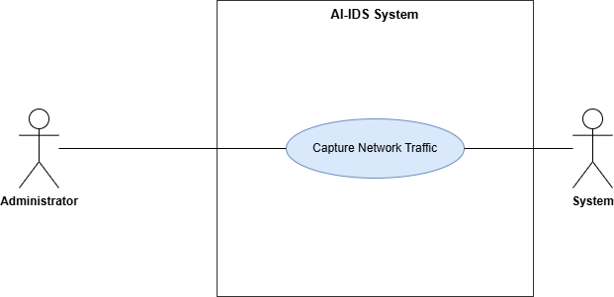
Figure 3.1 — Use Case Diagram: Capture network traffic

3.1.1 Use case detail
Use Case ID | UC_01
Use Case Name | Capture network traffic
Description | This use case describes how an administrator initiates the capture of real-time network traffic, or starts the dataset-based replay simulator, for analysis by the system.
Primary Actor | Administrator
Secondary Actor | System
Pre-Condition | The user is signed in as an administrator; the application is running with elevation; a valid network interface (and the Npcap driver) is available for live capture.
Post-Condition | Network flows are successfully captured (or replayed) and forwarded for processing.
Basic Flow | Actor Action | System Action
 | - Administrator selects a network interface (or chooses the replay source)  - Administrator starts capture (or replay)  - Administrator monitors traffic | - System lists available interfaces and verifies availability  - System begins collecting network flows  - System continuously forwards flows for preprocessing
Alternate Flow | If no network interface is available, the interface selection is disabled, and the administrator may use the replay simulator instead.

3.2 Use case — Preprocess network traffic
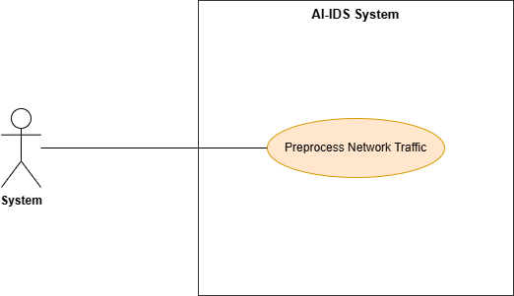
Figure 3.2 — Use Case Diagram: Preprocess network traffic

3.2.1 Use case detail
Use Case ID | UC_02
Use Case Name | Preprocess network traffic
Description | This use case describes how the system preprocesses captured network traffic and extracts the per-flow features required for classification.
Primary Actor | System
Secondary Actor
Pre-Condition | Network packets have been captured, or dataset records are available.
Post-Condition | A 50-feature flow vector is prepared and ready for classification
Basic Flow | Actor Action | System Action
 | - (Automated — no direct user action) | - System groups packets into flows using a 5-tuple with an inactivity timeout  - System computes the 50 required features for each flow  - System prepares the feature vector for classification
Alternate Flow | For offline data, the system maps the dataset's columns onto the unified 50-feature schema.

3.3 Use case — Classify network traffic
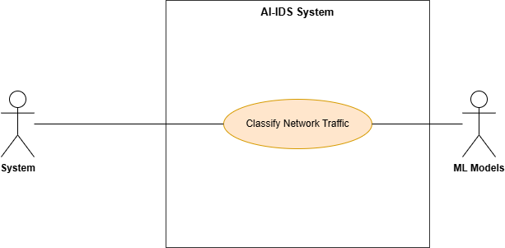

Figure 3.3 — Use Case Diagram: Classify network traffic

3.3.1 Use case detail
Use Case ID | UC_03
Use Case Name | Classify network traffic
Description | This use case describes how the system classifies a network flow as benign or malicious and, for malicious flows, identifies the attack family.
Primary Actor | System
Secondary Actor | Machine learning models
Pre-Condition | The trained models are loaded; the request originates locally.
Post-Condition | A classification label, confidence score, and attack type (for malicious flows) are produced and persisted.
Basic Flow | Actor Action | System Action
 | (Automated) | - System submits the feature vector to the binary classifier  - System applies the decision threshold to label the flow benign or attack  - If the flow is an attack, the system runs the multi-class classifier to identify the family and assigns severity
Alternate Flow | If the multi-class model is unavailable, the system operates in binary-only mode (benign/attack).

3.4 Use case — Generate alerts, logs, and mitigation information
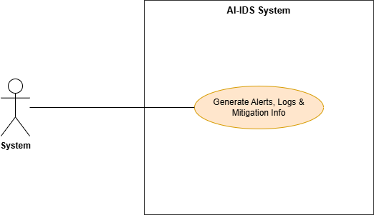

Figure 3.4 — Use Case Diagram: Generate alerts, logs, and mitigation information

3.4.1 Use case detail

Use Case ID | UC_04
Use Case Name | Generate alerts, logs, and mitigation information
Description | This use case describes how the system generates an alert, assigns severity, stores mitigation guidance, and persists the detection record when malicious activity is detected.
Primary Actor | System
Secondary Actor
Pre-Condition | A classification result has been produced.
Post-Condition | The flow, detection, alert, and mitigation records are persisted, and a backup log entry is written.
Basic Flow | Actor Action | System Action
 | (Automated) | - System assigns a severity level to the detected attack  - System writes the flow, detection, alert, and mitigation records in a single transaction  - System appends a backup log entry and makes the alert available on the dashboard
Alternate Flow | For benign traffic, only the flow and detection records are written; no alert is raised.

3.5 Use case — View alerts, logs, and mitigation information

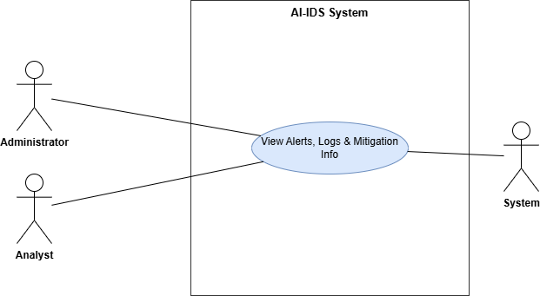

Figure 3.5 — Use Case Diagram: View alerts, logs, and mitigation information

3.5.1 Use case detail
Use Case ID | UC_05
Use Case Name | View alerts, logs, and mitigation information
Description | This use case describes how a signed-in user monitors detected intrusions, historical logs, and summary statistics through the SOC dashboard.
Primary Actor | Administrator / Analyst
Secondary Actor | System
Pre-Condition | The user is signed in.
Post-Condition | -
Basic Flow | Actor Action | System Action
 | - User opens the dashboard  - User reviews alerts and charts | - System retrieves current statistics, alerts, and status  - System renders KPIs, the alerts table, and charts
Alternate Flow | If the live alert cache is empty, the system falls back to the backup log.

3.6 Use case — Authenticate (login / logout)
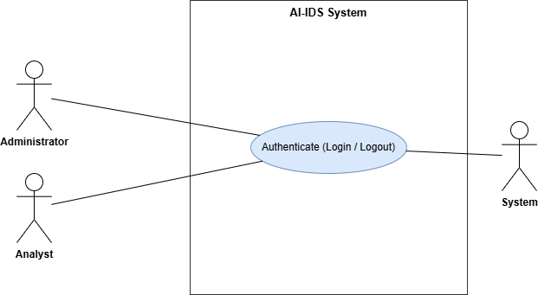
Figure 3.6 — Use Case Diagram: Authenticate

3.6.1 Use case detail
Use Case ID | UC_06
Use Case Name | Authenticate (login / logout)
Description | This use case describes how a user signs in to obtain a session and signs out to revoke it.
Primary Actor | Administrator / Analyst
Secondary Actor | System
Pre-Condition | The user account exists and is neither locked nor disabled.
Post-Condition | A session is created on login and revoked on logout; the event is recorded in the audit log.
Basic Flow | Actor Action | System Action
 | - User enters username and password  - User signs out | - System verifies the credentials against the stored hash  - System issues a session token and records the login  - System revokes the session and records the logout
Alternate Flow | -

3.7 Use Case — Manage users
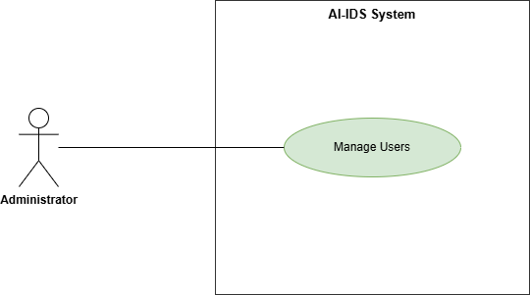
Figure 3.7 — Use Case Diagram: Manage users

3.7.1 Use case detail
Use Case ID | UC_07
Use Case Name | Manage users
Description | This use case describes how an administrator creates user accounts and changes roles, passwords, and account status.
Primary Actor | Administrator
Secondary Actor | -
Pre-Condition | The user is signed in as an administrator.
Post-Condition | The user account is created or updated, and the change is recorded in the audit log.
Basic Flow | Actor Action | System Action
 | - Administrator opens the user management page  - Administrator creates a user or edits a role, password, or status | - System displays the list of existing users  - System validates the input and saves the change  - System records the action in the audit log
Alternate Flow | Disabling a user automatically revokes that user's active sessions.

3.8 Use Case — Control traffic source
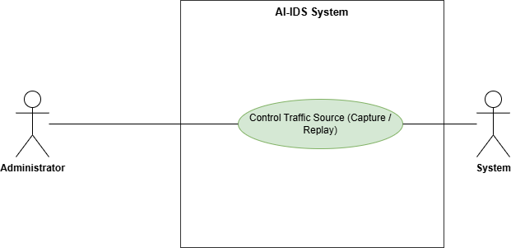
Figure 3.8 — Use Case Diagram: Control traffic source

3.8.1 Use case detail
Use Case ID | UC_08
Use Case Name | Control traffic source
Description | This use case describes how an administrator starts and stops the traffic sources — live packet capture and the dataset-based replay simulator.
Primary Actor | Administrator
Secondary Actor | System
Pre-Condition | The user is signed in as an administrator; for live capture, the application is elevated and a network interface is available.
Post-Condition | The selected traffic source begins or stops producing flows for analysis.
Basic Flow | Actor Action | System Action
 | - Administrator selects a traffic source and starts it  - Administrator stops the traffic source | - System begins capture or replay and reports the running state  - System stops capture or replay and updates the state
Alternate Flow | The administrator may run the replay simulator when no live interface is available.

3.9 Use Case — Request mitigation
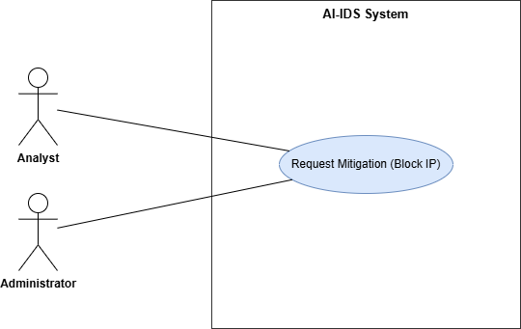
Figure 3.9 — Use Case Diagram: Request mitigation

3.9.1 Use case detail
Use Case ID | UC_09
Use Case Name | Request mitigation
Description | This use case describes how an analyst (or administrator) requests that the source IP address of a detected attack be blocked.
Primary Actor | Analyst
Secondary Actor | Administrator
Pre-Condition | The user is signed in; an attack alert with an identifiable source IP exists.
Post-Condition | A pending mitigation request is recorded and awaits administrator review.
Basic Flow | Actor Action | System Action
 | - User selects an attack alert and chooses to request a block  - User submits the block request | - System displays the attacker IP, excluding the system's own addresses  - System records a pending mitigation request and logs the action
Alternate Flow | The system removes duplicate source IPs so each attacker is requested only once.

3.10 Use Case — Approve / deny and enforce block
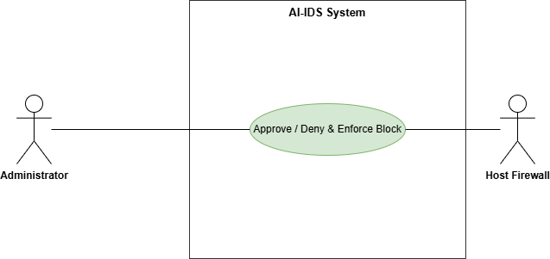
Figure 3.10 — Use Case Diagram: Approve / deny and enforce block

3.10.1 Use case detail
Use Case ID | UC_10
Use Case Name | Approve / deny and enforce block
Description | This use case describes how an administrator reviews a pending mitigation request and either denies it or approves it, in which case the system blocks the IP at the host firewall.
Primary Actor | Administrator
Secondary Actor | Host firewall
Pre-Condition | A pending mitigation request exists; the user is signed in as an administrator; the application is elevated.
Post-Condition | The request is approved or denied; on approval, a firewall block rule is applied and the action is recorded.
Basic Flow | Actor Action | System Action
 | - Administrator reviews a pending request  - Administrator approves the request  - Administrator denies the request (alternative) | - System displays the request details  - System applies a firewall block rule for the IP and records the action and audit trail  - System marks the request denied and records it
Alternate Flow | An administrator may deny their own request at any time.

3.11 Use Case — Unblock IP
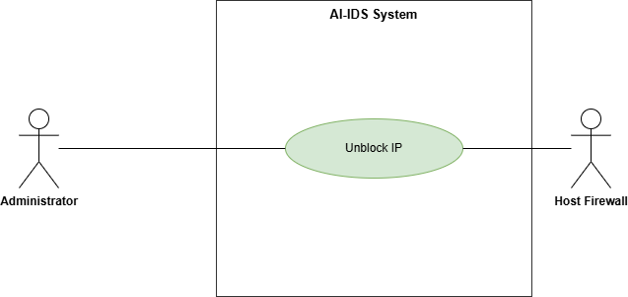
Figure 3.11 — Use Case Diagram: Unblock IP

3.11.1 Use case detail
Use Case ID | UC_11
Use Case Name | Unblock IP
Description | This use case describes how an administrator reverses a previously applied block and views the list of currently active blocks.
Primary Actor | Administrator
Secondary Actor | Host firewall
Pre-Condition | The user is signed in as an administrator; a prior block exists for the IP.
Post-Condition | The firewall block rule is removed and the action is recorded.
Basic Flow | Actor Action | System Action
 | - Administrator views the list of active blocks  - Administrator selects an IP and unblocks it | - System displays currently blocked Ips  - System removes the firewall rule, updates the ledger, and records the action
Alternate Flow | -

3.12 Use Case — View audit log
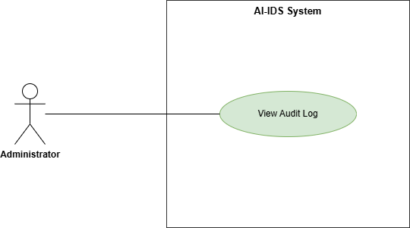
Figure 3.12 — Use Case Diagram: View audit log

3.12.1 Use case detail
Use Case ID | UC_12
Use Case Name | View audit log
Description | This use case describes how an administrator reviews and exports the append-only record of privileged actions and access denials.
Primary Actor | Administrator
Secondary Actor | -
Pre-Condition | The user is signed in as an administrator.
Post-Condition | The filtered audit records are displayed and can be exported.
Basic Flow | Actor Action | System Action
 | - Administrator opens the audit log page and applies filters  - Administrator reviews or exports the records | - System retrieves the matching audit records  - System displays the records and provides a CSV export
Alternate Flow | -

3.13 Use Case — Generate AI incident report
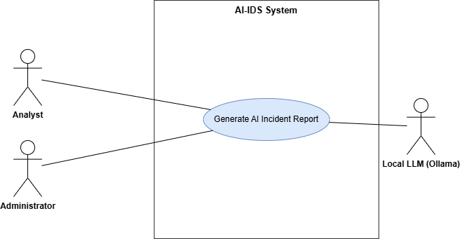

Figure 3.13 — Use Case Diagram: Generate AI incident report

3.13.1 Use case detail
Use Case ID | UC_13
Use Case Name | Generate AI incident report
Description | This use case describes how a signed-in user generates a plain-language incident report for a detected attack, produced locally by a language model. The report is advisory and read-only.
Primary Actor | Administrator / Analyst
Secondary Actor | Local language model service
Pre-Condition | The user is signed in; at least one attack alert exists; the local language model service is running.
Post-Condition | A plain-language incident report is displayed to the user and can be downloaded. No system data is modified.
Basic Flow | Actor Action | System Action
 | - User selects an attack alert and requests a report  - User reads or downloads the report | - System retrieves the stored details for that alert  - System sends the details to the local language model and receives a report  - System displays the report and offers a download option
Alternate Flow | If the language model service is offline, the system shows an advisory notice and continues operating normally.

Chapter 4: Design

In this section, we provide the design analysis of our modules including the following designs
- Architecture Diagram
- ERD with data dictionary
- Data Flow diagram
- Class Diagram
- Activity Diagram
- Sequence Diagram
- Collaboration Diagram
- State Transition Diagram
- Component Diagram
- Deployment Diagram

Architecture Diagram
The system architecture diagram provides a high-level view of the overall structure of the system, organized into presentation, logic, and data layers. The presentation layer is the operator's SOC dashboard; the logic layer is the controller and REST API that drive detection, access control, and mitigation; and the data layer holds the trained models, the local database, and the host firewall the system acts upon. This layered organization shows how user interaction flows down to the processing core and how that core relies on local storage and enforcement resources, supporting near-real-time intrusion detection and controlled threat mitigation on a single host.

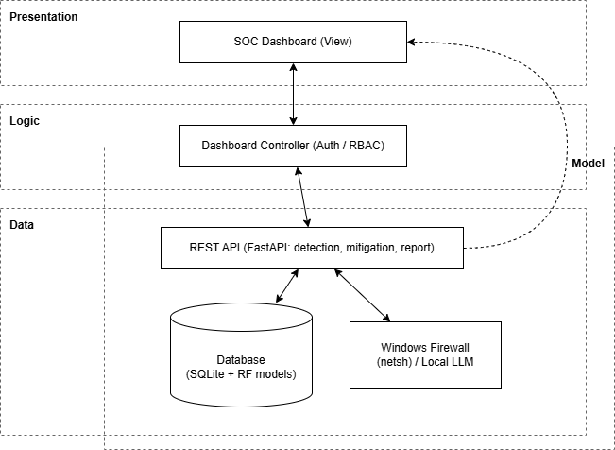
Figure 4.1 Architecture Diagram

ERD with data dictionary
The entity relationship diagram illustrates the logical structure of the data used by the system. It defines the entities involved in traffic monitoring, detection results, alert logging, mitigation recommendations, the human-in-the-loop blocking workflow, and user, session, and audit management, along with the relationships between them. Primary and foreign keys maintain referential integrity and ensure proper linkage between captured traffic, classification outcomes, generated alerts, mitigation actions, and the operators who performed them. The Phase 1 detection tables are preserved unchanged, while Phase 2 adds the authentication, audit, and mitigation tables additively.

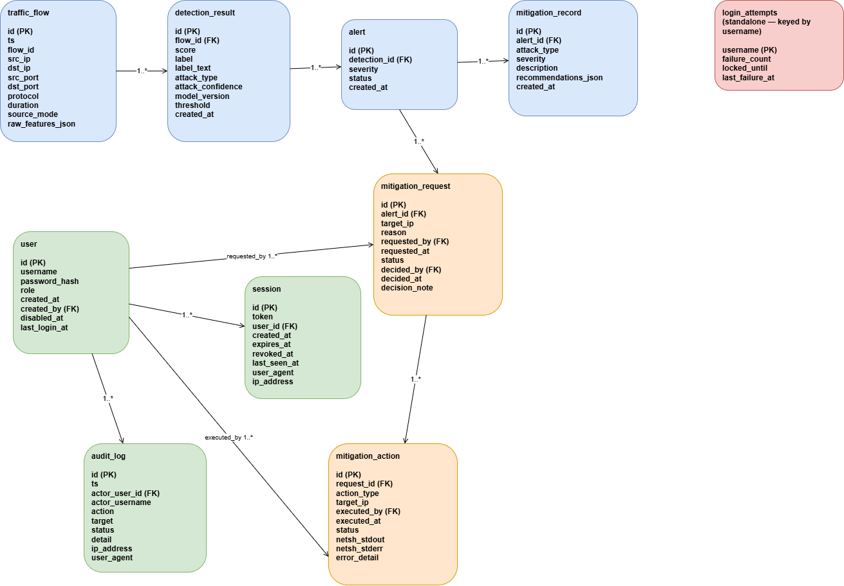

Figure 4.2 ERD

Data dictionary
Entity | Purpose
traffic_flow | One row per analyzed flow; stores flow metadata and the raw feature vector.
detection_result | Classification outcome for a flow (score, label, attack type, threshold, model version).
alert | Raised only for malicious flows; carries severity and open/closed status.
mitigation_record | Snapshot of recommended response actions for an alert.
user | Operator accounts with role (admin/analyst) and status.
session | Issued login sessions (opaque token, expiry, revocation).
audit_log | Append-only record of privileged actions and access denials.
mitigation_request | Analyst-raised request to block an attacker IP, with decision fields.
mitigation_action | Executed block/unblock action and its firewall result.
login_attempts | Per-username failed-login counter for lockout.

Data Flow diagram
Data flow diagram includes two levels

The level 0
The level 0 data flow diagram provides a high-level overview by showing how data flows between external entities and the system as a whole. It represents the system as a single process and helps in understanding the overall data exchange without exposing internal details.

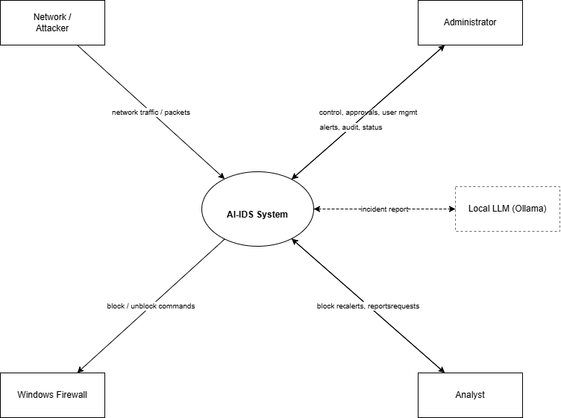

Figure 4.3.1 Level 0 DFD

The level 1
The level 1 data flow diagram decomposes the main system process into its internal processes. It shows how network traffic is captured, preprocessed, classified, and stored, how alerts and mitigation information are generated, how the human-in-the-loop blocking workflow operates, and how authentication and auditing wrap the privileged actions.

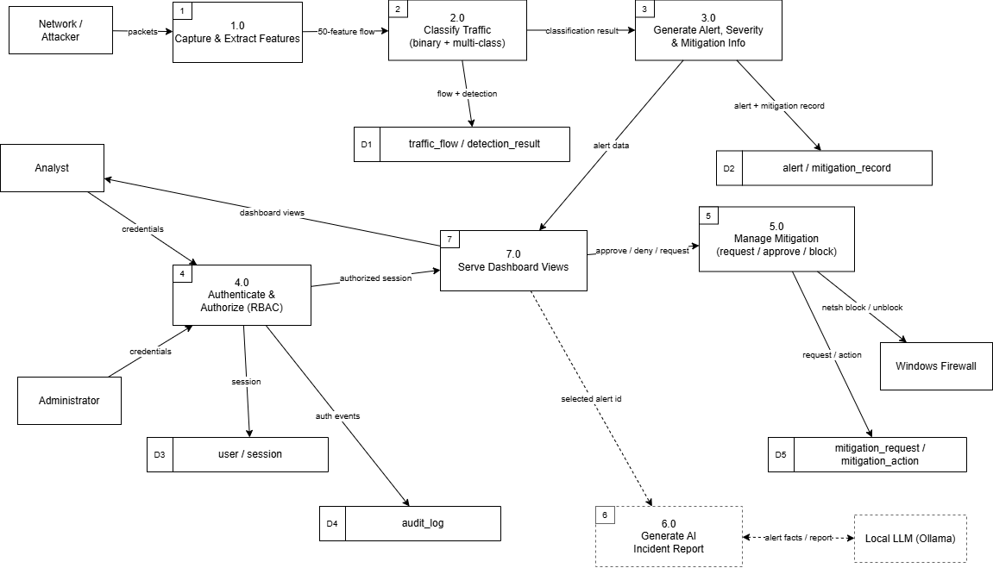

Figure 4.3.2 Level 1 DFD

Class Diagram
The class diagram describes the static structure of the system by showing the main classes, their attributes and methods, and their relationships. It represents how the system components are organized at an implementation level, covering the detection pipeline, the classification models, persistence, authentication, and the mitigation workflow. Generalization is used where the two classifiers share a common model base and where the block and unblock operations share a common mitigation-action base.

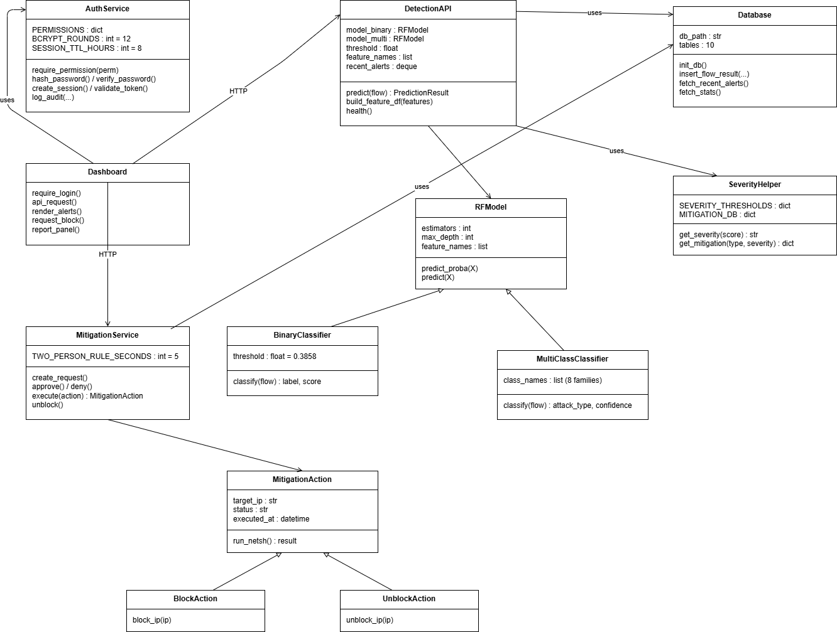

Figure 4.4 Class Diagram

Activity Diagram

The activity diagrams represent the workflow of the system for each major function. The activity diagrams represent the workflow of the system for each major function. They illustrate the sequence of actions, decision points, and control flow involved in traffic capture, preprocessing, classification, alert generation, the mitigation workflow, viewing, and incident reporting. Activity diagrams are provided for the workflow-significant functions; closely related requirements are grouped into a shared diagram, so all functional requirements are covered. They illustrate the sequence of actions, decision points, and control flow involved in traffic capture, preprocessing, classification, alert generation, the mitigation workflow, viewing, and incident reporting.

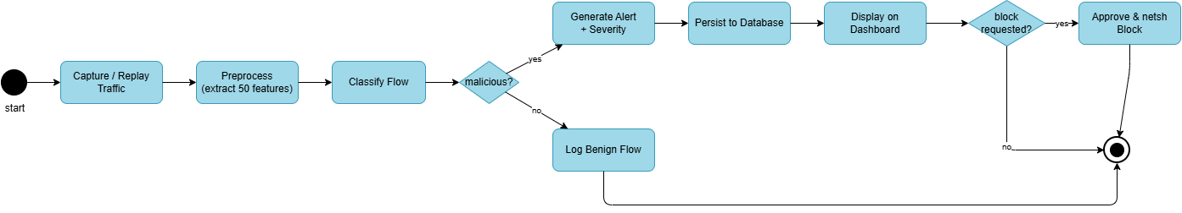

Figure 4.5 Aggregated Activity Diagram

    - Activity Diagram capture network traffic

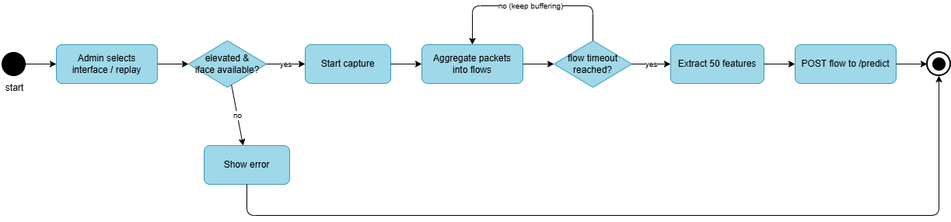

Figure 4.5.1 Activity Diagram capture network traffic

    - Activity Diagram preprocess network traffic

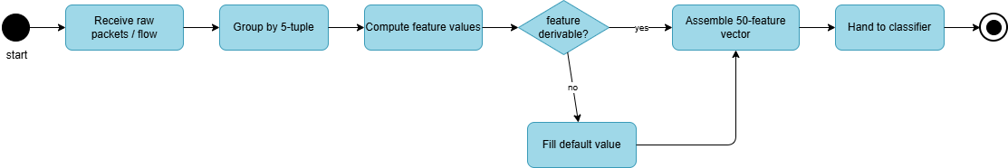

Figure 4.5.2 Activity Diagram preprocess network traffic

    - Activity Diagram preprocess network traffic
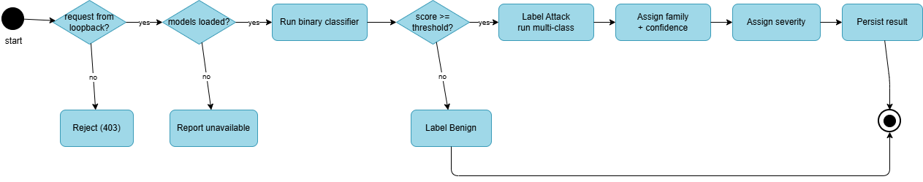

Figure 4.5.3 Activity Diagram classify network traffic

    - Activity Diagram generate alerts, logs, and mitigation information

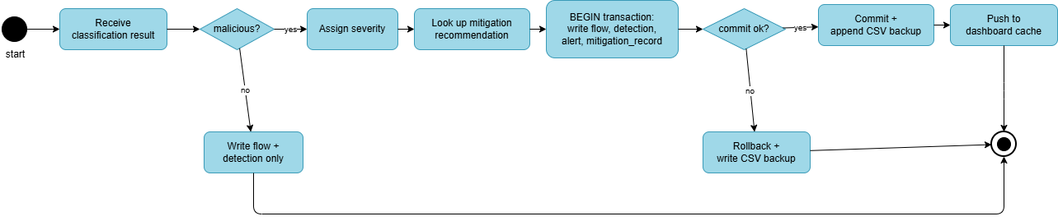
Figure 4.5.4 Activity Diagram generate alerts, logs, and mitigation information

    - Activity Diagram view alerts, logs, and mitigation information

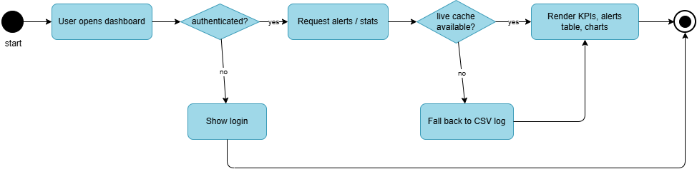
Figure 4.5.5 Activity Diagram view alerts, logs, and mitigation information

    - Activity Diagram mitigation workflow
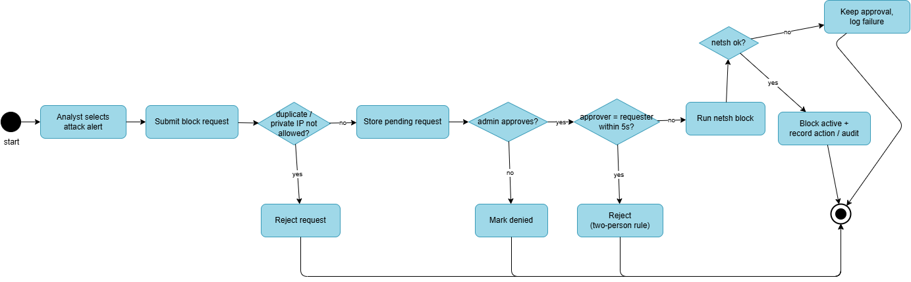
Figure 4.5.6 Activity Diagram mitigation workflow

    - Activity Diagram generate AI incident report

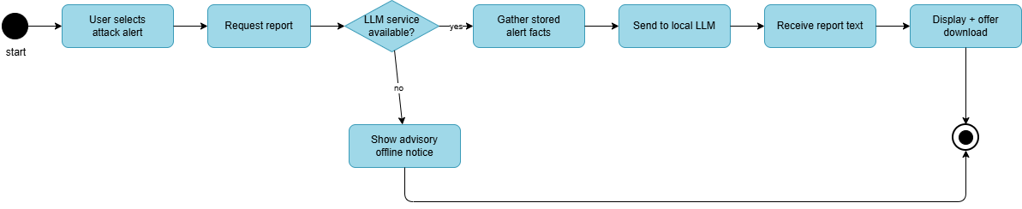

Figure 4.5.7 Activity Diagram generate AI incident report

Sequence Diagram
The sequence diagrams show the interaction between system components in time order. They explain how messages are exchanged between the user, the dashboard, the backend API, the models, the database, the firewall, and the local report service during each function.

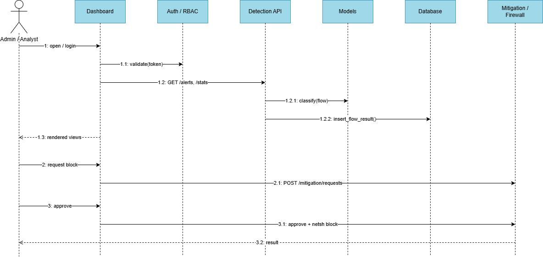

Figure 4.6 Aggregated Sequence Diagram

    - Sequence Diagram Capture network traffic

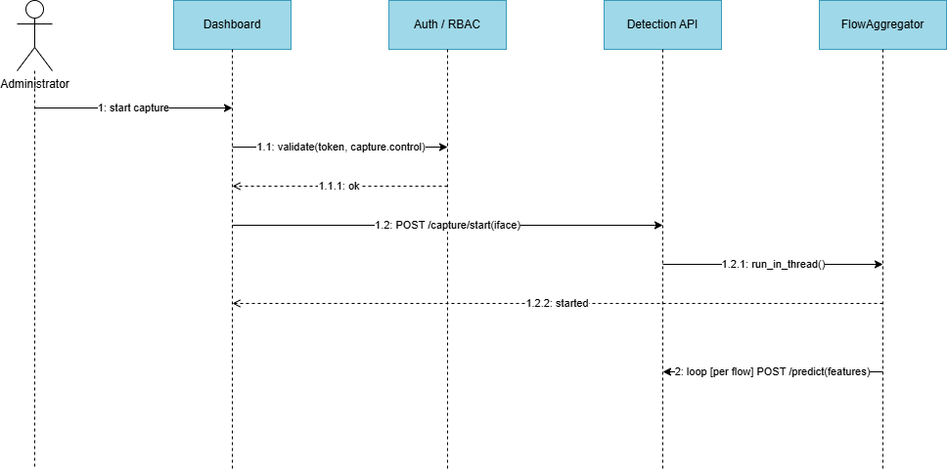

Figure 4.6.1 Sequence Diagram Capture network traffic

    - Sequence Diagram preprocess network traffic

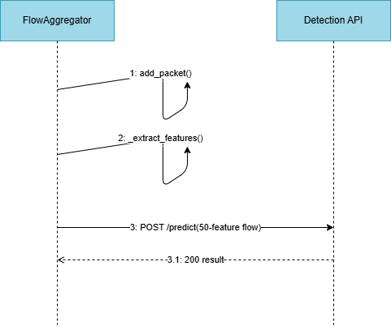

Figure 4.6.2 Sequence Diagram preprocess network traffic

    - Sequence Diagram classify network traffic

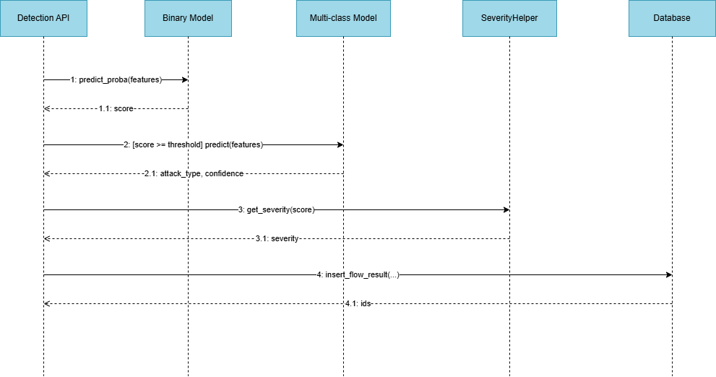
Figure 4.6.3 Sequence Diagram classify network traffic

    - Sequence Diagram Generate alerts, logs, and mitigation information

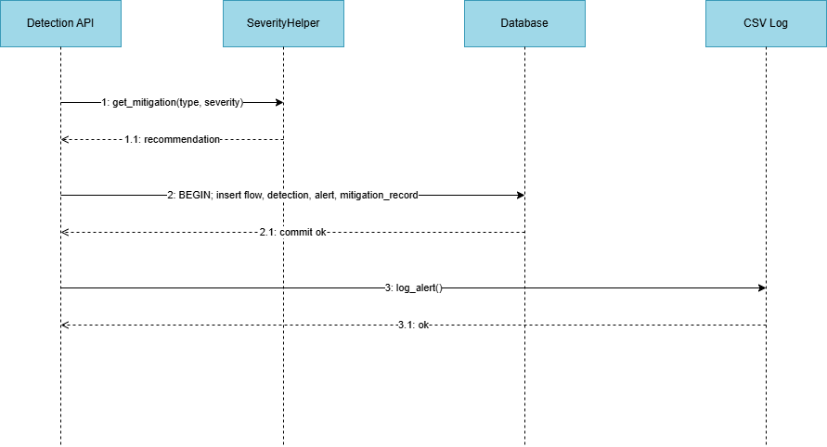
Figure 4.6.4 Sequence Diagram Generate alerts, logs, and mitigation information

    - Sequence Diagram view alerts, logs, and mitigation information
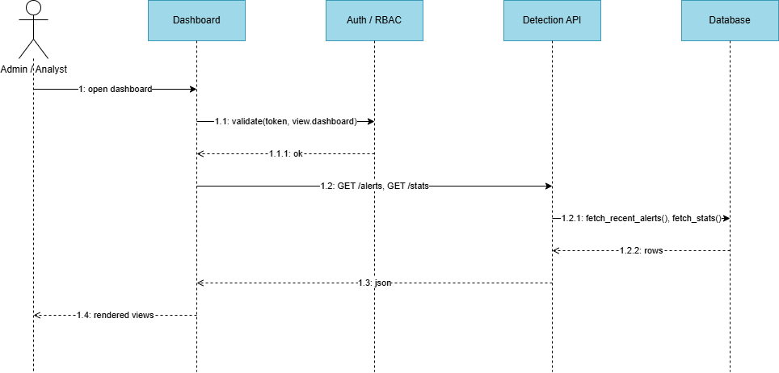

Figure 4.6.5 Sequence Diagram view alerts, logs, and mitigation information

    - Sequence Diagram authenticate

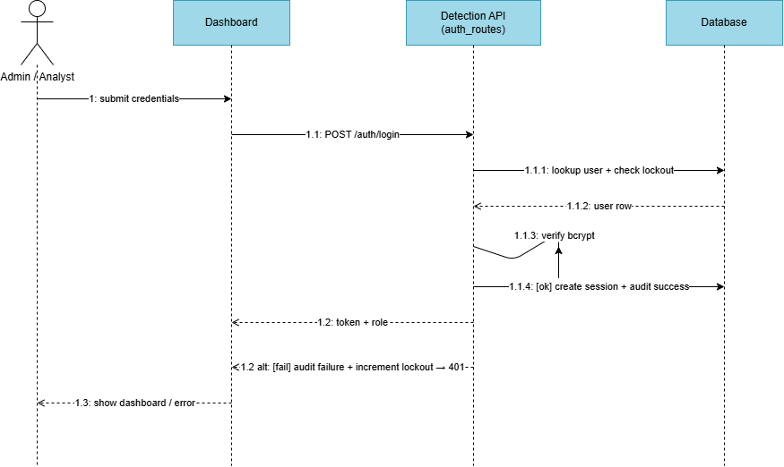

Figure 4.6.6 Sequence Diagram authenticate
    - Sequence Diagram mitigation workflow

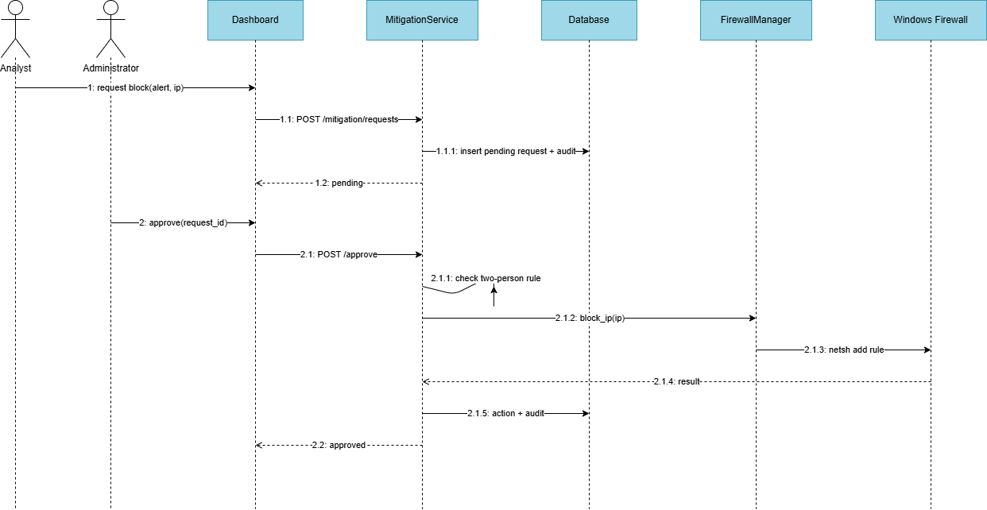
Figure 4.6.7 Sequence Diagram mitigation workflow

    - Sequence Diagram generate AI incident report

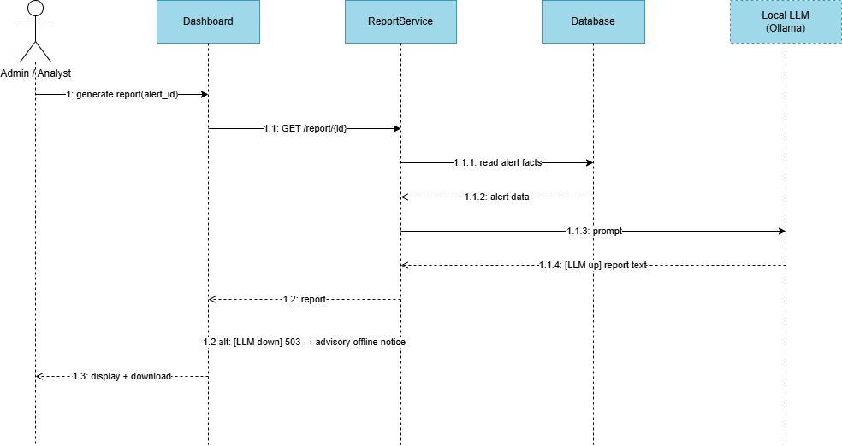
Figure 4.6.8 Sequence Diagram generate AI incident report

Collaboration Diagram
The collaboration diagram focuses on object interaction and communication structure within the system. It represents how objects collaborate and shows the order of method calls using numbered messages to achieve the required functionality. This diagram presents the main detection-to-mitigation collaboration.

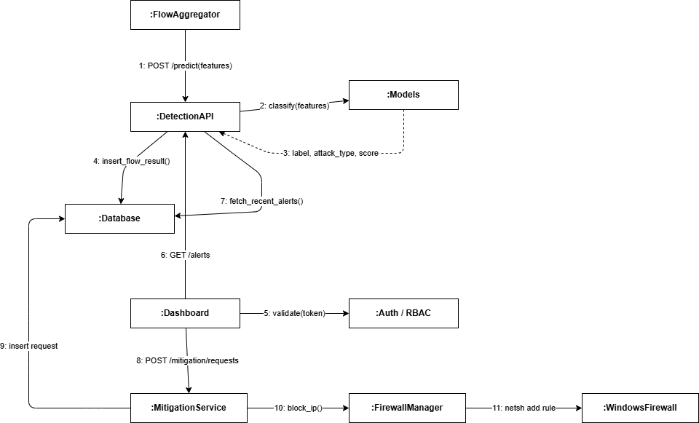

Figure 4.7 Collaboration Diagram

State Transition Diagram
The state transition diagram illustrates the lifecycle of a mitigation request as it moves through the human-in-the-loop workflow, from creation by an analyst to final enforcement or reversal. It shows how the system transitions between states based on operator actions and firewall outcomes.

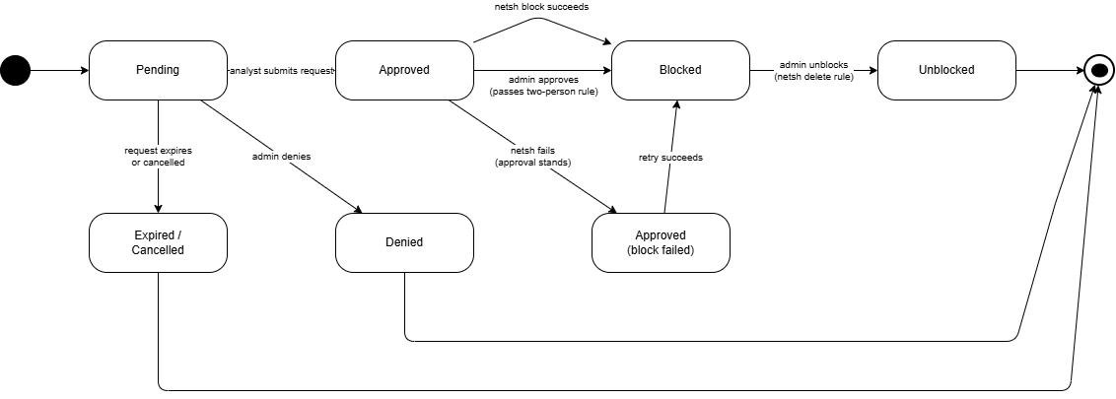
Figure 4.8 State Transition Diagram

Component Diagram
The component diagram presents the physical organization of the software components and their dependencies. It shows the major implementation modules and how they interact to deliver detection, access control, mitigation, and reporting.

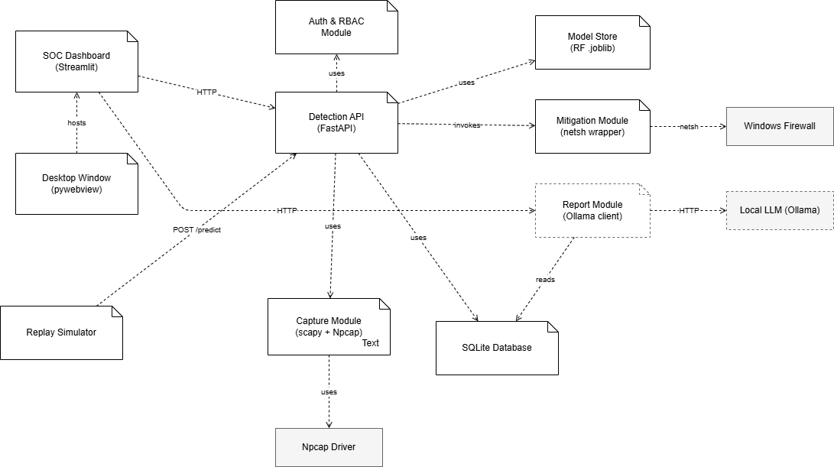

Figure 4.9 Component Diagram

Deployment Diagram
The deployment diagram represents the physical deployment of the system. It illustrates how the software components are deployed on a single standalone Windows host, with an isolated attacker virtual machine used only for validation. It highlights local processing, local storage, and the loopback-only communication between the dashboard and the backend.

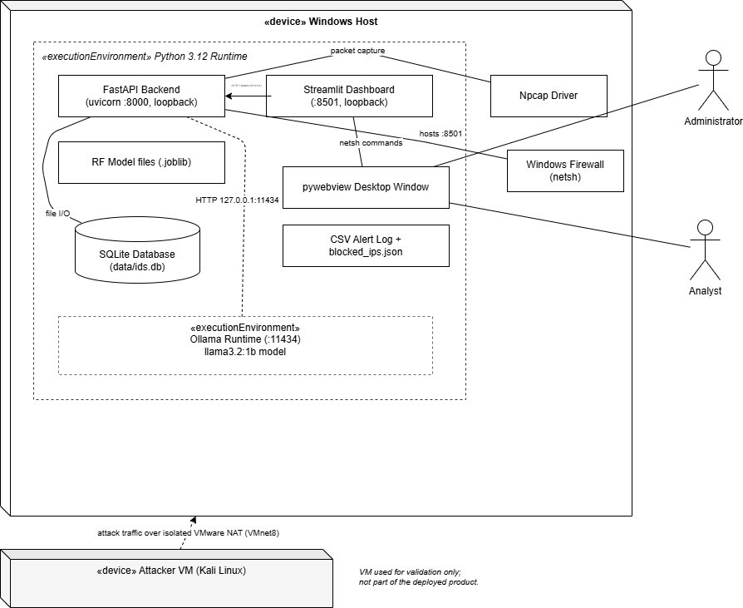

Figure 4.10 Deployment Diagram

Chapter 5: Testing
This chapter presents the testing performed on the AI-driven intrusion detection and threat mitigation system. Testing combined an automated test suite of 24 tests (run with pytest) covering the firewall wrapper, the mitigation workflow, the authentication and lockout logic, and an end-to-end smoke test, together with black-box functional testing of the user-facing features and real-attack validation in an isolated laboratory.

Test Case Specifications
This section presents representative test cases for the functional requirements of the project, following the standard positive/negative test-case format. Each test case below corresponds to one or more automated tests that were executed and passed.

Test Case for Capture network traffic
 | Positive Test Case
ID | TC_CAPTURE_SUCCESS
Priority | High
Description | To verify the system captures live traffic (or replays dataset traffic) from a selected source.
Reference | FR_01 (Capture network traffic).
Users | Administrator.
Pre-requisites | A | The system is running with administrator elevation
 | B | A valid network interface with the Npcap driver is available.
Steps | A | Open the dashboard.
 | B | Select a network interface
 | C | Start capture.
Input | Selected network interface or replay parameters.
Expected result | The system begins collecting network flows in real time and forwards them for analysis.
Status | Tested, passed.

Table 5.1 Positive Test Case

 | Negative Test Case
ID | TC_CAPTURE_NOT_ELEVATED
Priority | Medium
Description | To verify live capture is refused when the application lacks administrator elevation.
Reference | FR_01 (Capture network traffic).
Users | Administrator.
Pre-requisites | A | The system is running without administrator elevation.
Steps | A | Open the dashboard.
 | B | Select a network interface.
 | C | Start capture.
Input | Start-capture request from a non-elevated process.
Expected result | The system refuses with an "administrator required" message and does not start capture.
Status | Tested, passed.

Table 5.2 Negative Test Case

Test Case for Preprocess and extract features
 | Positive Test Case
ID | TC_PREPROCESS_SUCCESS
Priority | High
Description | To verify captured packets are aggregated into flows and reduced to the 50-feature vector.
Reference | FR_02 (Preprocess and extract features).
Users | System
Pre-requisites | A | Packets have been captured, or dataset records are available.
Steps | A | Receive raw packets.
 | B | Group by flow.
 | C | Compute features.
Input | Raw network packets or dataset records.
Expected result | A complete 50-feature flow vector is produced; any feature that cannot be derived is filled with a default value so classification can proceed.
Status | Tested, passed.

Table 5.3 Positive Test Case

Test Case for Classify network traffic

 | Positive Test Case
ID | TC_CLASSIFY_SUCCESS
Priority | High
Description | To verify the system classifies a submitted flow and returns a label and score.
Reference | FR_03 (Classify network traffic).
Users | System
Pre-requisites | A | The models are loaded.
 | B | The request originates from the local host.
Steps | A | Submit a 50-feature flow vector to the prediction endpoint.
Input | A 50-feature flow vector.
Expected result | The system returns a label (benign or attack) and a score in the range 0 to 1; attack flows also receive an attack type and severity.
Status | Tested, passed.

Table 5.4 Positive Test Case

 | Negative Test Case
ID | TC_CLASSIFY_NONLOOPBACK
Priority | High
Description | To verify the prediction endpoint refuses non-local callers.
Reference | FR_03 (Classify network traffic).
Users | System
Pre-requisites | A | The system is running.
Steps | A | Submit a prediction request from a non-loopback address.
Input | A prediction request originating from a remote address.
Expected result | The request is refused with a "forbidden" response and no classification is performed.
Status | Tested, passed.

Table 5.5 Negative Test Case

Test Case for Generate alerts, logs, and mitigation information
 | Positive Test Case
ID | TC_ALERT_GENERATION
Priority | High
Description | To verify an alert, severity, mitigation guidance, and persisted records are produced for a malicious flow.
Reference | FR_04 (Generate alerts, logs, and mitigation information).
Users | System
Pre-requisites | A | A classification result indicating an attack is available.
Steps | A | Receive an attack classification.
 | B | Assign severity.
 | C | Persist the records.
Input | An attack classification result.
Expected result | The flow, detection, alert, and mitigation records are written in a single transaction, a backup log entry is appended, and the alert appears on the dashboard.
Status | Tested, passed.

Table 5.6 Positive Test Case

View alerts, logs, and mitigation information

 | Positive Test Case
ID | TC_VIEW_DASHBOARD
Priority | Medium
Description | To verify an authenticated user can view alerts, logs, and statistics on the dashboard.
Reference | FR_05 (View alerts, logs, and mitigation information).
Users | Administrator, Analyst
Pre-requisites | A | The user is signed in.
 | B | Alerts or logs exist.
Steps | A | Open the dashboard.
 | B | Review the alerts table and charts.
Input | An active session.
Expected result | Current statistics, alerts, severity levels, and charts are displayed; if the live cache is empty, the system falls back to the backup log.
Status | Tested, passed.

Table 5.7 Positive Test Case

Test Case for User login and logout

 | Positive Test Case
ID | TC_LOGIN_SUCCESS
Priority | High
Description | To verify user authentication with valid credentials.
Reference | FR_06 (User login and logout).
Users | Administrator, Analyst
Pre-requisites | A | The system is running.
 | B | The user has an active account that is neither locked nor disabled.
Steps | A | Open the dashboard.
 | B | Enter username.
 | C | Enter password.
 | D | Press Login.
Input | Valid username and password.
Expected result | The user is authenticated, a session is issued, and the dashboard opens with role-appropriate options.
Status | Tested, passed.

Table 5.8 Positive Test Case

 | Negative Test Case
ID | TC_LOGIN_FAILURE
Priority | High
Description | To verify invalid credentials are rejected and the account locks after repeated failures.
Reference | FR_06 (User login and logout).
Users | Administrator, Analyst
Pre-requisites | A | The system is running.
Steps | A | Open the dashboard.
 | B | Enter username.
 | C | Enter an incorrect password.
 | D | Press Login.
Input | Incorrect password; five consecutive wrong attempts.
Expected result | Access is denied with a generic "Invalid credentials" message; after five failed attempts the account is locked for fifteen minutes, and a correct password is still refused while locked.
Status | Tested, passed.

Table 5.9 Negative Test Case

Test Case for Role-based access control
 | Positive Test Case
ID | TC_RBAC_ALLOW
Priority | High
Description | To verify each role can perform the actions permitted to it.
Reference | FR_07 (Role-based access control).
Users | Administrator, Analyst
Pre-requisites | A | A valid session for the relevant role is active.
Steps | A | Perform an action permitted for the role.
Input | A request carrying a valid session token for a permitted action.
Expected result | The action is allowed and performed.
Status | Tested, passed.

Table 5.10 Positive Test Case

 | Negative Test Case
ID | TC_RBAC_DENY
Priority | High
Description | To verify an analyst cannot perform administrator-only actions, and unauthenticated requests are refused.
Reference | FR_07 (Role-based access control).
Users | Analyst
Pre-requisites | A | An analyst session is active.
Steps | A | Attempt an administrator-only action (approve or unblock).
 | B | Attempt a request with no token.
Input | Analyst token for a privileged action; and, separately, no token.
Expected result | The privileged action is refused with a "forbidden" response for the analyst, and the tokenless request is refused with an "unauthorized" response.
Status | Tested, passed.

Table 5.11 Negative Test Case

Test Case for User management
 | Positive Test Case
ID | TC_USER_CREATE
Priority | High
Description | To verify an administrator can create and modify user accounts.
Reference | FR_08 (User management).
Users | Administrator.
Pre-requisites | A | An administrator session is active.
Steps | A | Open the user management page.
 | B | Create a user or edit a role/password/status.
Input | Username, role, password, and status fields.
Expected result | The account is created or updated, and the change is recorded in the audit log.
Status | Tested, passed.

Table 5.12 Positive Test Case

 | Negative Test Case
ID | TC_USER_SELF_PROTECT
Priority | Medium
Description | To verify an administrator cannot remove their own admin role or disable their own account, and duplicate usernames are rejected.
Reference | FR_08 (User management).
Users | Administrator.
Pre-requisites | A | An administrator session is active.
Steps | A | Attempt to self-demote or self-disable.
 | B | Attempt to create a user with an existing username.
Input | A self-demotion/self-disable request; a duplicate username.
Expected result | The self-protection actions are refused, and the duplicate username is rejected.
Status | Tested, passed.

Table 5.13 Negative Test Case

Test Case for Audit logging
 | Positive Test Case
ID | TC_AUDIT_VIEW
Priority | Medium
Description | To verify privileged actions are recorded and an administrator can filter and export the audit log.
Reference | FR_09 (Audit logging).
Users | Administrator.
Pre-requisites | A | An administrator session is active
 | B | Privileged actions have occurred.
Steps | A | Open the audit log page
 | B | Apply filters.
 | C | Export to CSV.
Input | Filter criteria
Expected result | The matching append-only audit records are displayed and can be exported; the log contains login, user-creation, and mitigation events.
Status | Tested, passed.

Table 5.14 Positive Test Case

Test Case for Request Mitigation
 | Positive Test Case
ID | TC_MITIGATION_REQUEST
Priority | High
Description | To verify an analyst or administrator can request that an attacker IP be blocked.
Reference | FR_10 (Request mitigation).
Users | Analyst, Administrator
Pre-requisites | A | The user is signed in
 | B | An attack alert with a source IP exists.
Steps | A | Select an attack alert.
 | B | Submit a block request.
Input | Alert identifier and target IP.
Expected result | A pending mitigation request is recorded and the action is logged.
Status | Tested, passed.

Table 5.15 Positive Test Case

 | Negative Test Case
ID | TC_MITIGATION_DUPLICATE
Priority | Medium
Description | To verify duplicate pending requests and disallowed IPs are rejected.
Reference | FR_10 (Request mitigation).
Users | Analyst
Pre-requisites | A | A pending request already exists for the target IP.
Steps | A | Submit a second block request for the same IP.
 | B | Submit a request for a private IP without the lab override.
Input | A duplicate target IP; a private IP.
Expected result | The duplicate is rejected with the existing request identifier, and the private IP is rejected unless the laboratory override is enabled.
Status | Tested, passed.

Table 5.16 Negative Test Case

Test Case for Approve/deny and enforce block
 | Positive Test Case
ID | TC_MITIGATION_APPROVE
Priority | High
Description | To verify an administrator can approve a pending request, enforcing a firewall block.
Reference | FR_11 (Approve/deny and enforce block).
Users | Administrator.
Pre-requisites | A | A pending request exists.
 | B | The administrator session is active and the process is elevated..
Steps | A | Open the mitigation page.
 | B | Approve the pending request.
Input | Request identifier and approval decision.
Expected result | The request becomes approved, a firewall block rule is applied, the action is recorded, and audit rows for request, approval, and block execution are written.
Status | Tested, passed.

Table 5.17 Positive Test Case

 | Negative Test Case
ID | TC_MITIGATION_SELF_APPROVE
Priority | High
Description | To verify a user cannot approve their own request within the two-person rule window, and a non-pending request cannot be re-approved.
Reference | FR_11 (Approve/deny and enforce block).
Users | Administrator.
Pre-requisites | A | A request created by the same administrator less than five seconds earlier.
Steps | A | The original requester attempts to approve it.
 | B | Attempt to approve an already-approved request.
Input | Self-approval within five seconds; a second approval of an approved request.
Expected result | The self-approval is rejected by the two-person rule with no block executed and a failure audit row; the re-approval is rejected as already approved.
Status | Tested, passed.

Table 5.18 Negative Test Case

Test Case for Unblock IP
 | Positive Test Case
ID | TC_UNBLOCK_SUCCESS
Priority | Medium
Description | To verify an administrator can reverse a previously applied block.
Reference | FR_12 (Unblock IP).
Users | Administrator.
Pre-requisites | A | An administrator session is active.
 | B | A prior approved block exists for the IP.
Steps | A | View active blocks
 | B | Select an IP and unblock it.
Input | Target IP.
Expected result | The firewall rule is removed, the ledger is updated, the action is linked to the prior request, and a success audit row is written.
Status | Tested, passed.

Table 5.19 Positive Test Case

 | Negative Test Case
ID | TC_UNBLOCK_NO_PRIOR
Priority | Medium
Description | To verify an unblock is refused for an IP that was never the subject of a request.
Reference | FR_12 (Unblock IP).
Users | Administrator.
Pre-requisites | A | An administrator session is active.
Steps | A | Attempt to unblock an IP with no prior mitigation request.
Input | An IP with no prior request.
Expected result | The unblock is refused with an error and no firewall command is executed.
Status | Tested, passed.

Table 5.20 Negative Test Case

Test Case for Generate AI incident report
 | Positive Test Case
ID | TC_AI_REPORT_SUCCESS
Priority | Low
Description | To verify a plain-language incident report is generated for an attack alert.
Reference | FR_13 (Generate AI incident report).
Users | Administrator, Analyst
Pre-requisites | A | The user is signed in
 | B  C | An attack alert exists  The local language model service is running.
Steps | A | Select an attack alert.
 | B | Request a report.
Input | Selected attack alert identifier.
Expected result | A plain-language report (summary, details, severity justification, recommended actions) is displayed and can be downloaded; no system data is modified.
Status | Tested, passed.

Table 5.21 Positive Test Case

 | Negative Test Case
ID | TC_AI_REPORT_LLM_DOWN
Priority | Low
Description | To verify graceful degradation when the local language model service is unavailable.
Reference | FR_13 (Generate AI incident report).
Users | Administrator, Analyst
Pre-requisites | A  B | The user is signed in  The local language model service is not running.
Steps | A  B | Select an attack alert.  Request a report.
Input | Report request while the language model is offline.
Expected result | The system shows an advisory offline notice and continues operating normally; no other function is affected.
Status | Tested, passed.

Table 5.22 Negative Test Case

Black Box Test Cases
Black-box testing, also known as behavioral testing, is a method in which the internal structure, design, or implementation of the item being tested is not known to the tester; tests are derived from the requirements and the expected externally observable behavior. The following black-box techniques were applied to the system.

Equivalence Partitions (EP)
In equivalence partitioning, the input domain is divided into classes (partitions) that are expected to be treated the same way by the system, and one representative value is tested from each. The table below shows the valid and invalid partitions for the system's key inputs.

Variables | Valid Classes | Invalid Classes
Username | 3–32 characters, letters/digits/underscore | Empty; under 3 or over 32 characters; characters outside the allowed set
Password (at creation) | 12 or more characters | Fewer than 12 characters; empty
Login credentials | Correct username and password for an active account | Wrong password; non-existent user; disabled or locked account
Prediction input | A 50-feature flow vector from a loopback caller | Non-loopback caller; missing model
Mitigation target IP | Valid public IP address | Private/loopback/link-local IP (unless lab override); empty or malformed IP
Mitigation request state (for approval) | Pending request approved by a different user | Self-approval within five seconds; already-approved or denied request

Table 5.23 Equivalence Partitioning — Valid and Invalid Classes

Boundary Value Analysis

Values at the edges of input ranges were tested. The clearest boundary is the login lockout threshold: the account remains usable through four consecutive failed attempts, locks at the fifth, and a correct password is still refused while locked. Testing confirmed the counter resets atomically after a success, so four failures, then a success, then four more failures (eight total) still do not lock the account. The classification threshold is a second boundary: a flow scoring just below the threshold is labelled benign while one at or above it is labelled an attack. A third boundary is the password length rule, where 11 characters is rejected and 12 is accepted.

Decision Table Testing
The mitigation approval logic was tested as a decision table over the conditions (requester identity, elapsed time since the request, request status, and firewall outcome). The combinations verified include: approver differs from requester → block proceeds; approver equals requester within five seconds → rejected by the two-person rule; request already approved → second approval rejected; and firewall command fails → approval still stands with the failure recorded rather than reverted.

State transition Testing
The mitigation request lifecycle (Chapter 4, Figure 4.8) was tested across its states. A request moves from Pending to Approved to Blocked on the normal path, from Pending to Denied when refused, and from Blocked to Unblocked when reversed. The tests confirmed valid transitions succeed and invalid ones are refused — for example, approving a request that is not in the Pending state is rejected.

Use Case Testing
Each use case from Chapter 3 was exercised end-to-end. The smoke test covers the principal chain in a single run: an administrator and an analyst log in, a flow is classified, the analyst raises a mitigation request, the administrator approves it, a user is created, and the audit log is then confirmed to contain the login, user-creation, request, approval, and block events — verifying the use cases work together as an integrated workflow.

White Box Test Cases
White-box testing, also known as structural or glass-box testing, examines the internal logic and structure of the code. Tests are derived from the control flow inside each function so that the independent paths through the code are exercised.

Cyclomatic complexity
Cyclomatic complexity (the McCabe metric) measures the number of linearly independent paths through a function, which gives a lower bound on the number of test cases needed for full branch coverage — a higher value means more decision points and more paths to test. The complexity of the entire src/ codebase was measured with the radon tool (version 6.0.1) using the command python -m radon cc src/ -s -a. Radon grades each block on the standard McCabe bands shown below.

Rank | CC range | Interpretation
A | 1–5 | Simple, low risk
B | 6–10 | Well-structured, low risk
C | 11–20 | Moderate
D | 21–30 | Needs attention
E | 31–40 | High risk
F | 41+ | Very high risk

Across 126 analysed blocks (functions, methods, and classes), the average cyclomatic complexity was A (4.72), indicating that the codebase is low-complexity and well-structured on average, with the large majority of blocks falling in rank A. The table below lists the most complex functions, which represent the structural hotspots that justify the most test paths.

Cyclomatic Complexity | Rank | Function | File
56 | F | main | src/data/prep_cic2017.py
17 | C | predict | src/serve/app.py
17 | C | capture_interfaces | src/serve/app.py
17 | C | users_patch | src/serve/auth_routes.py
16 | C | map_family | src/data/prep_cic2017.py
13 | C | lifespan | src/serve/app.py
12 | C | _extract_features | src/capture/live_capture.py
11 | C | validate_ip | src/mitigation/firewall.py
11 | C | load_dataset | src/models/train.py
11 | C | incident_report | src/serve/report_routes.py

Table 5.24 Highest Cyclomatic Complexity Functions

Performance testing
Performance testing verifies that the system processes and classifies traffic with low enough latency to be useful in near-real time. The detection path is a single Random Forest inference over a 50-feature vector, which completes quickly once the models are loaded into memory at startup. The dashboard refreshes every four seconds, the capture pipeline flushes flows on a three-second interval with a five-second flow timeout, and replayed traffic is processed continuously without backlog. In testing, alerts produced by classification appeared on the dashboard within the normal refresh cycle, confirming near-real-time presentation. The automated suite itself completed all 24 tests in 55.12 seconds; most of that time is accounted for by bcrypt password hashing in the authentication and lockout tests and by the one-time machine-learning model load during the smoke test's application startup, rather than by per-request processing.

Stress Testing
Stress testing observes the system under sustained and elevated load. During the laboratory validation the system processed continuous attack traffic from session-based tools — slowhttptest holding 200 concurrent connections, nikto issuing several thousand HTTP requests, and medusa performing rapid SSH authentication attempts — while simultaneously capturing, classifying, persisting, and displaying results. Across two independent runs the system remained responsive and did not crash or lose data. Detection records were written in single database transactions with a backup CSV log, so that a transient storage problem could not silently discard a detection. The system's reliability requirement — to operate continuously during a monitoring session and tolerate traffic variation without failure — was met under this load.

System Testing
System testing validates the complete, integrated system against its requirements rather than individual components. The end-to-end smoke test exercises the full chain in a single run: the application boots and reports healthy, all nine core database tables are present, an administrator and an analyst authenticate, a flow is classified through the prediction endpoint, the analyst raises a mitigation request, the administrator approves it (enforcing a firewall block), a new user is created, and the audit log is then confirmed to contain the login, user-creation, mitigation-request, approval, and block-execution events. This confirms that detection, persistence, authentication, access control, mitigation, and auditing function together as one system. Beyond the automated chain, the system was also validated manually through the dashboard and against real attacks in the laboratory, confirming the same behavior in actual use.

Regression Testing
Regression testing ensures that changes made during development did not break previously working functionality. Because the Phase 1 detection core (the models, the feature schema, and the prediction contract) was deliberately frozen and extended only additively, the automated test suite served as the regression safety net throughout Phase 2: it was re-run after each change to confirm that the existing detection, authentication, and mitigation behavior continued to pass.

Final Regression Tests
A final regression test validates a build that has been stable for a period and is ready to be shipped or submitted. As the final regression check for this project, the complete suite of 24 tests was run against the submission build and reported all tests passing in 55.12 seconds, with no failures, errors, or skips. This confirms the build is internally consistent and that all tested functionality works end to end in the version being submitted.

Regression Tests
A normal regression test is performed to verify that a recent change — whether a defect fix or an enhancement — has not broken any other part of the application. Throughout Phase 2, each time a feature was added (authentication, then the mitigation workflow, then the AI report) or a defect was fixed, the full automated suite was re-run to confirm the previously working subsystems still passed. Because the suite is fast and requires no special setup, this normal regression check was practical to perform on every change rather than occasionally.

Selecting Regression Tests
The regression set is the full automated suite of 24 tests, chosen because it is fast (under one minute), requires no administrator elevation, no network interface, no attacker virtual machine, and no antivirus change, and covers every Phase 2 subsystem: the firewall wrapper, the mitigation endpoints and their access-control and two-person rules, the login and lockout hardening, and the end-to-end integration chain. Its speed and zero-setup nature make it practical to run on every change rather than selectively.

Regression Testing Steps
The regression procedure is: (A) activate the project virtual environment; (B) run the full suite with \.venv\Scripts\python.exe -m pytest tests/ -v; (C) confirm the summary reports all tests passed with no failures, errors, or skips; and (D) if any test fails, fix the regression before proceeding, then re-run the full suite to confirm it is green again. Following this procedure, the final run reported all 24 tests passing in 55.12 seconds.

Chapter 6: Tools and Techniques

This chapter describes the programming languages, applications and tools, and libraries used in the development of the AI-driven intrusion detection and threat mitigation system. All components are open-source or freely available for academic use, in keeping with the project's open-source licensing constraint, and the system runs entirely offline on a single Windows host.

6.1 Languages
Python is the single core programming language used across the entire system. It implements the packet-capture and feature-extraction pipeline, the machine-learning training and inference code, the REST backend, the dashboard, the authentication and mitigation logic, and all supporting utilities and tools. Python was chosen for its mature machine-learning and data-handling ecosystem and its strong support for rapid development.
SQL is used for all data persistence. The schema definitions, queries, and transactional writes that store traffic flows, detection results, alerts, mitigation records, users, sessions, the audit log, and the mitigation workflow are expressed in the SQLite dialect of SQL.
In addition, the dashboard renders parts of its alert table using small fragments of HTML and CSS (for severity colour-coding and layout), and the firewall mitigation feature issues commands through the Windows netsh command-line interface. These are supporting interfaces rather than primary development languages.

6.2 Applications and Tools
The following applications and tools were used during development, testing, and deployment:
• Visual Studio Code — primary code editor and development environment.
• Git — version control for the project source code.
• Uvicorn — the ASGI server that hosts the FastAPI backend on the local loopback interface.
• Npcap — the Windows packet-capture driver (WinPcap-compatible mode) required for live network traffic capture. [4]
• Windows Firewall / netsh advfirewall — the host firewall and its command-line interface, used to enforce approved IP blocks.
• Ollama — a local large-language-model runtime used to generate advisory incident reports; it runs on the loopback interface and is optional (the system functions fully without it). [5]
• VMware Workstation — used to host the isolated Kali Linux attacker virtual machine for real-attack validation.
• Kali Linux (with slowhttptest, medusa, and nikto) — the attacker environment and session-based attack tools used to validate detection against real traffic.
• pytest — the framework used to run the automated test suite.
• draw.io (diagrams.net) — used to produce the UML and system-design diagrams in this document.

6.3 Libraries and Extensions
The system is built on the following open-source Python libraries:
• scikit-learn — builds, trains, and runs the two-stage Random Forest classification models, including the preprocessing pipeline and threshold tuning. [6]
• joblib — serializes and loads the trained model files.
• NumPy — numerical array operations used throughout feature extraction, training, and inference.
• pandas — tabular data handling for training data, feature alignment at prediction time, and dashboard tables.
• pyarrow — reads and writes the Parquet training-data files.
• Scapy — captures live network packets and enumerates network interfaces (using the Npcap driver on Windows).
• FastAPI — the web framework that implements the REST backend (detection, authentication, mitigation, and reporting endpoints). [7]
• Uvicorn — the ASGI server that runs the FastAPI application.
• Streamlit — builds the security operations (SOC) dashboard interface. [8]
• streamlit-autorefresh — provides the periodic auto-refresh of the live dashboard.
• Plotly — renders the score-distribution histogram and source-IP charts on the dashboard.
• pywebview — wraps the Streamlit dashboard in a native desktop window so the system runs as a desktop application.
• requests — the HTTP client used for internal communication between components and for calls to the local LLM runtime.
• passlib (with bcrypt) — provides secure one-way password hashing for user accounts.
• bcrypt — the hashing backend used by passlib (cost factor 12).
• matplotlib — generates optional training and evaluation plots (such as the threshold-tuning curve and confusion matrix).

6.4 Techniques
Beyond the tools above, the system applies several established techniques:
- Supervised machine learning (Random Forest) with a two-stage classification design — a binary stage (benign vs. malicious) followed by a multi-class stage that identifies the attack family.
- Flow-based feature extraction — network packets are aggregated into bidirectional flows and reduced to a fixed 50-feature vector for classification.
- Threshold tuning — the binary decision threshold is selected to maximise the F1 score on the precision–recall curve rather than using a default of 0.5.
- Role-based access control (RBAC) with opaque, server-side session tokens and an append-only audit trail.
- Human-in-the-loop mitigation with a two-person approval rule before any firewall enforcement.

Chapter 7: Summary and Conclusion

7.1 Summary
This project set out to design and build an AI-driven intrusion detection and threat mitigation system for secure networks, operating as a standalone application on a single Windows host. The system captures network traffic — either live from a network interface or through a dataset-based replay simulator — aggregates it into per-flow feature vectors, and classifies each flow using trained Random Forest models in two stages: a binary stage that separates benign from malicious traffic, and a multi-class stage that identifies the attack family of malicious flows. When an attack is detected, the system assigns a severity level, stores attack-specific mitigation guidance, and persists the full record in a local SQLite database with referential integrity.
Building on the detection core delivered and defended in Phase 1, Phase 2 extended the system to address the three questions raised during the Phase 1 evaluation. First, to answer how the system would be operated and controlled, a two-role access-control model (administrator and analyst) was added, backed by securely hashed passwords, server-side sessions, login lockout, and an append-only audit log of every privileged action. Second, to demonstrate that detection works against real attacks rather than only replayed traffic, the system was validated in an isolated Kali Linux laboratory using session-based attack tools. Third, to move beyond detection alone, a human-in-the-loop mitigation workflow was implemented in which an analyst requests that an attacker address be blocked and an administrator reviews and approves the request, after which the block is enforced at the host firewall through the Windows netsh interface, subject to a two-person approval rule. In addition, an advisory AI incident-report feature was added, using a locally hosted language model to produce plain-language summaries of detected attacks without affecting detection or enforcement.
All functionality is presented through a security operations dashboard delivered as a native desktop application, and the entire system runs offline with no dependency on cloud services or external infrastructure.

7.2 Conclusion
The project successfully delivered a working, end-to-end intrusion detection and threat mitigation system that meets the functional and non-functional requirements defined for it. The detection model performed strongly on the dataset on which it was evaluated and detected real, session-based attacks in a controlled laboratory environment, confirming that the approach generalises beyond replayed data. The access-control, auditing, and human-in-the-loop mitigation capabilities together turn a detection-only prototype into a small but complete and auditable security operations tool suitable for academic and small-scale environments.
The project also clarified the system's boundaries. Detection is reliable for session-based attacks that resemble the training distribution but does not extend to single-packet scan or flood traffic, which falls outside that distribution; mitigation is deliberately host-level and human-approved rather than automatic or network-wide; and the advisory reporting feature is exactly that — advisory — and never participates in detection or enforcement decisions. These boundaries were chosen intentionally to keep the system honest, controllable, and deliverable within the scope of a single-host academic project, and they define a clear and well-understood foundation for the future enhancements discussed in Chapter 9.

Chapter 8: User Manual

The user manual is an important part of an application's documentation. It is a guide for users on the operations available within the application. This chapter provides a step-by-step guide on how to start the system and use its main features through the security operations (SOC) dashboard. The system runs as a desktop application on a single Windows host; live packet capture and firewall mitigation require the application to be run with administrator privileges.

8.1 Starting the System
The system is started by running the launcher as administrator. Once the backend and dashboard services are running, the dashboard opens automatically in a native desktop window.
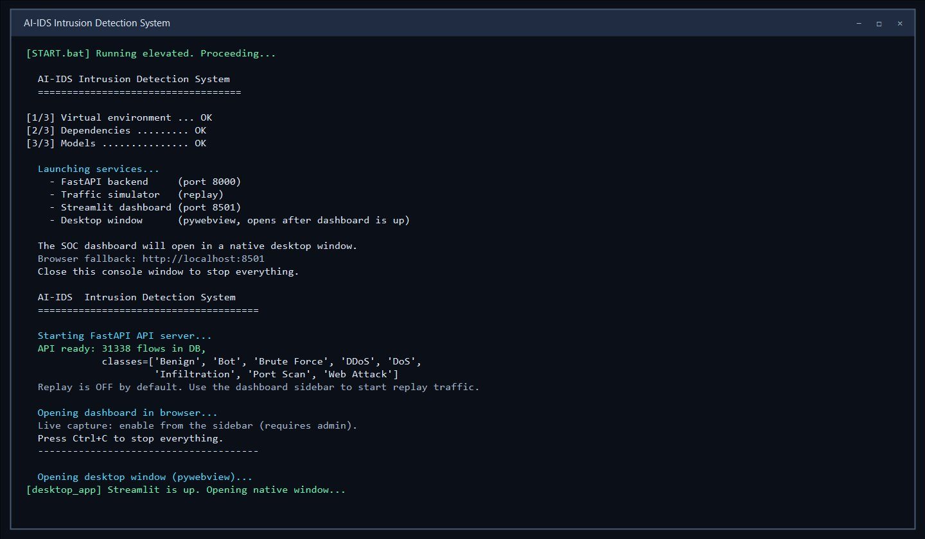
Figure 8.1 — Application starting / launcher screen
This is the start-up of the system, where the backend services and the dashboard are launched together.
Steps:
- Right-click the START.bat launcher and choose "Run as administrator."
- Wait for the backend service to start and report healthy.
- The dashboard opens in its own desktop window (it can also be reached in a browser at the local dashboard address).
- Done — the login screen is displayed

8.2 Login
The login screen is where a user signs in to the system. The user must have an active username and password and an assigned role (administrator or analyst).
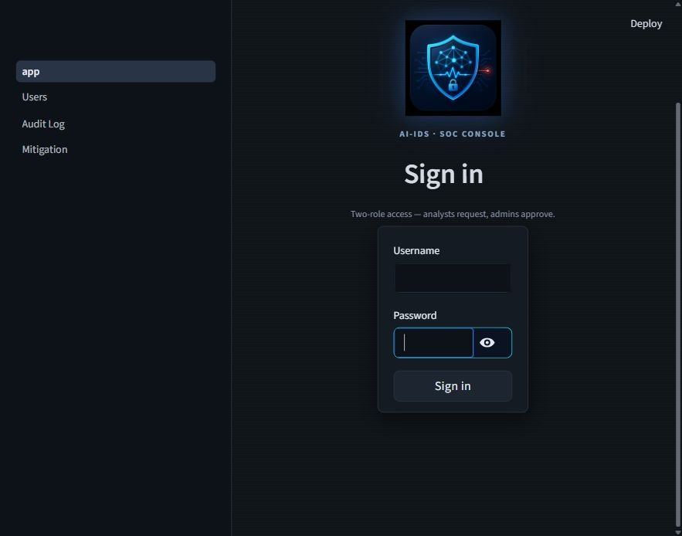
Figure 8.2 — Login screen
This is the login authentication screen from where the user can log in to the system.
Steps:
- Open the application (the login screen is shown on start-up).
- Enter the username.
- Enter the password.
- Click Login.
- Done — the dashboard opens with the options available to the user's role.

8.3 Dashboard Overview
After login, the main dashboard provides a high-level overview of network activity and detection performance. It shows the system status, key metrics, the recent alerts table, and summary charts.
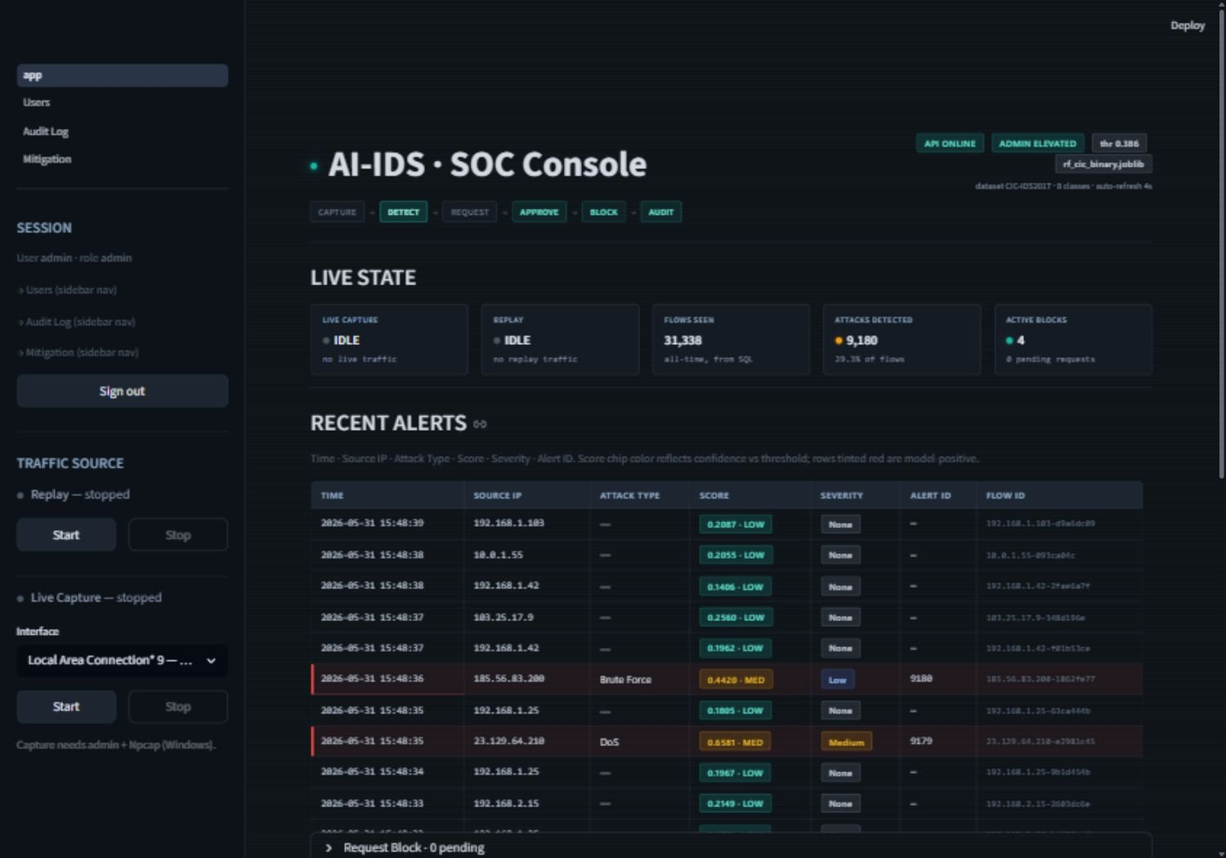
Figure 8.3 — Main SOC dashboard overview
This is the main dashboard. It displays the API and elevation status, the active detection threshold and model version, a live-state summary (flows seen, attacks detected, active blocks), and the recent alerts.
Information displayed:
- System status indicators (API online/offline, administrator-elevated state, threshold and model version).
- Live-state cards: live capture status, replay status, flows seen, attacks detected with rate, and active blocks with pending count.
- The recent alerts table.
- Score-distribution and top-source charts.
Steps:
- Log in to the system.
- View the status indicators and live-state cards at the top.
- Review the recent alerts and charts below.

8.4 Starting Traffic Capture or Replay
An administrator controls the traffic source from the sidebar — either live packet capture on a selected network interface, or the dataset-based replay simulator for demonstration.
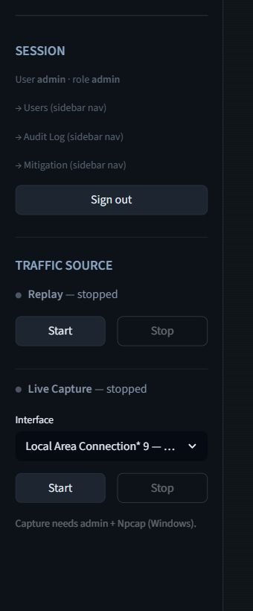
Figure 8.4 — Sidebar traffic source controls (capture / replay)
This is the traffic-source control in the sidebar, available to administrators, used to start and stop live capture or the replay simulator.
Steps:
- Log in as an administrator (the application must be running as administrator for live capture).
- In the sidebar, choose the traffic source.
- For live capture, select a network interface from the dropdown and click Start Capture; for replay, click Start Replay.
- Watch the live-state cards and recent alerts begin to populate.
- Click Stop when finished.

8.5 Real-Time Alert Monitoring
The recent alerts section displays the live classification results for incoming traffic. Each flow is labelled and colour-coded so threats are easy to spot.
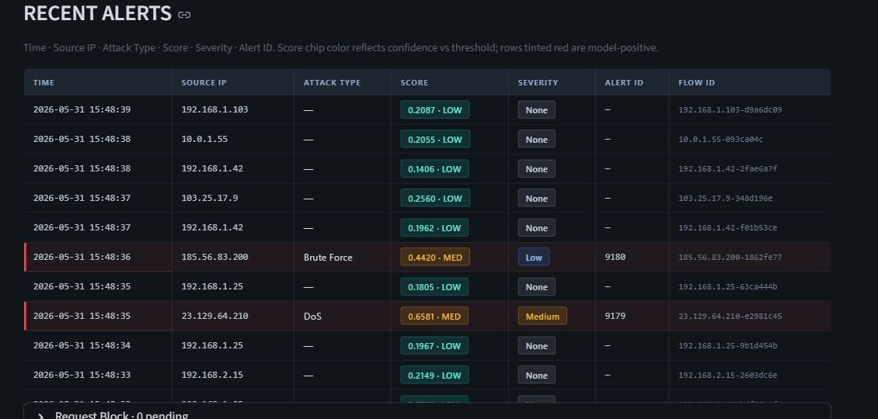
Figure 8.5 — Recent alerts table with attack rows highlighted
This is the recent alerts table. Each row shows the time, source IP, attack type, score, severity, alert ID, and flow ID; attack rows are highlighted so malicious traffic is easy to identify.
Steps:
- Start a traffic source (capture or replay).
- Observe the recent alerts table updating automatically.
- Read each alert's attack type, score, and severity.
- Identify highlighted attack rows for follow-up.

8.6 Requesting a Block (Analyst)
When an attack is detected, an analyst (or administrator) can request that the attacker's IP address be blocked. The request is held for administrator approval.
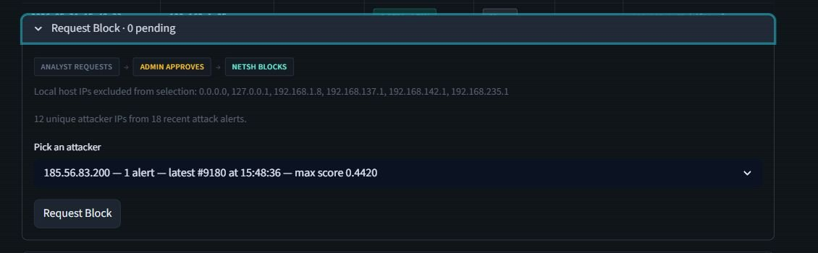
Figure 8.6 — Request Block panel
This is the Request Block panel. It lists attack source IPs (excluding the system's own addresses) and lets the user submit a block request for review.
Steps:
- Log in as an analyst or administrator.
- Open the Request Block panel.
- Select the attacker IP from an attack alert.
- Submit the block request.
- Done — the request is recorded as pending and awaits administrator approval.

8.7 Approving a Block and Enforcing Mitigation (Administrator)
An administrator reviews pending block requests on the Mitigation page and approves or denies them. On approval, the system blocks the IP at the host firewall. A user cannot approve their own request within the two-person rule window.
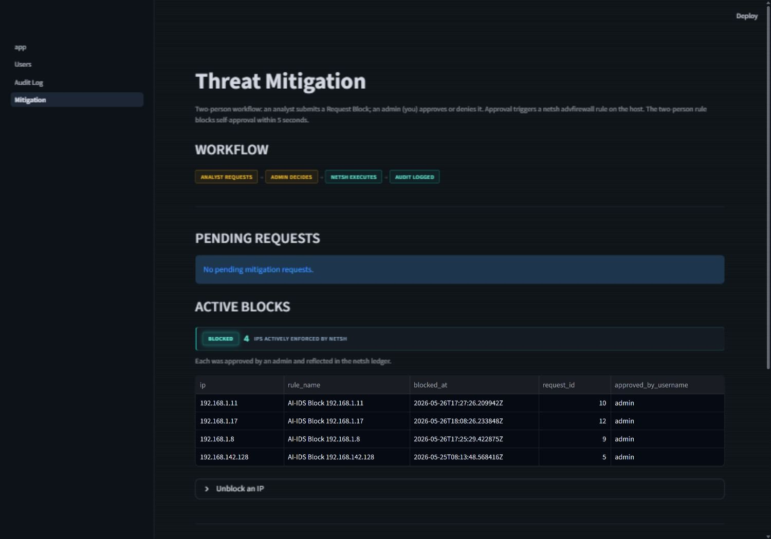
Figure 8.7 — Mitigation page: pending requests and active blocks
This is the Mitigation page, available to administrators. It shows pending requests with Approve and Deny buttons, the list of active blocks with an Unblock option, and any recent failed firewall executions.
Steps:
- Log in as an administrator (the application must be running as administrator).
- Open the Mitigation page.
- Review the pending request details.
- Click Approve to block the IP, or Deny to reject the request.
- Confirm the new block appears in the Active Blocks list.
- To reverse a block, click Unblock next to the active block.

8.8 Managing Users (Administrator)
An administrator manages user accounts on the Users page — creating accounts, changing roles or passwords, and enabling or disabling users.
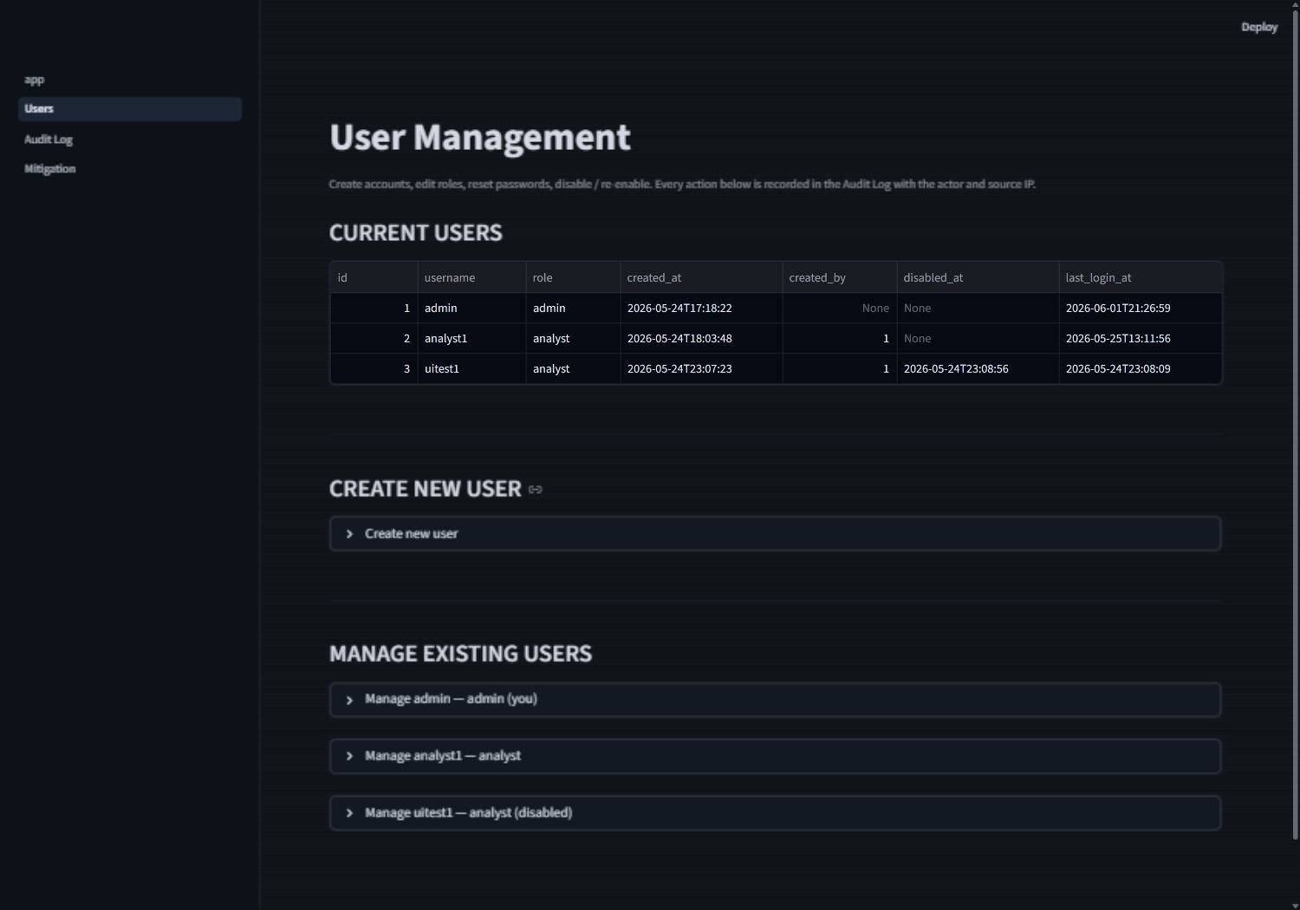
Figure 8.8 — Users management page
This is the Users page, available to administrators. It lists existing users and provides controls to create a user and to change a user's role, password, or status.
Steps:
- Log in as an administrator.
- Open the Users page.
- To create a user, enter a username, role, and password, then submit.
- To modify a user, change the role, reset the password, or disable/enable the account.
- Done — the change is saved and recorded in the audit log.

8.9 Viewing the Audit Log (Administrator)
The audit log records every privileged action and access denial. An administrator can filter the log and export it.
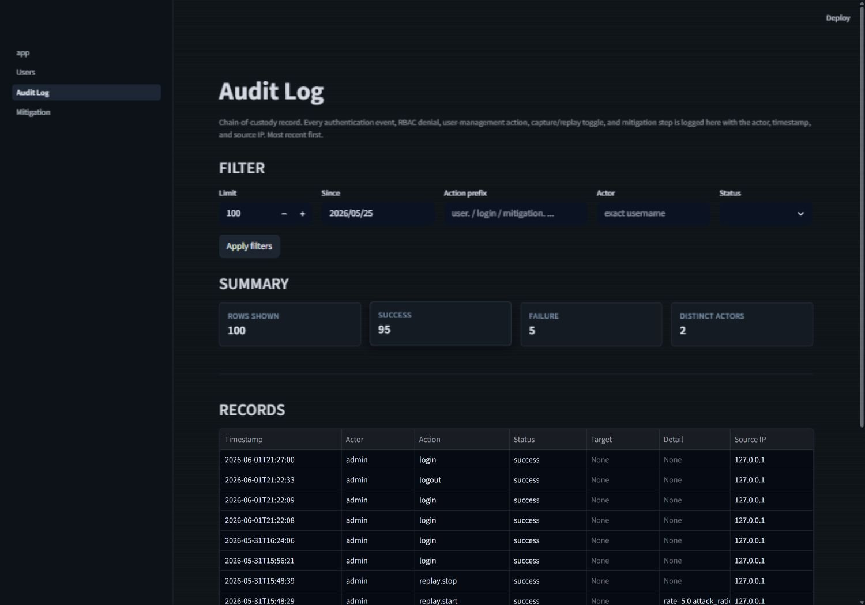
Figure 8.9 — Audit log page
This is the Audit Log page, available to administrators. It shows the append-only record of actions and allows filtering and CSV export.
Steps:
- Log in as an administrator.
- Open the Audit Log page.
- Apply filters (by action, actor, status, or date) as needed.
- Review the records, or click Export to download them as a CSV file.

8.10 Generating an AI Incident Report
For any detected attack, a user can generate a plain-language incident report produced by a local language model. The report is advisory only and does not change any system data.
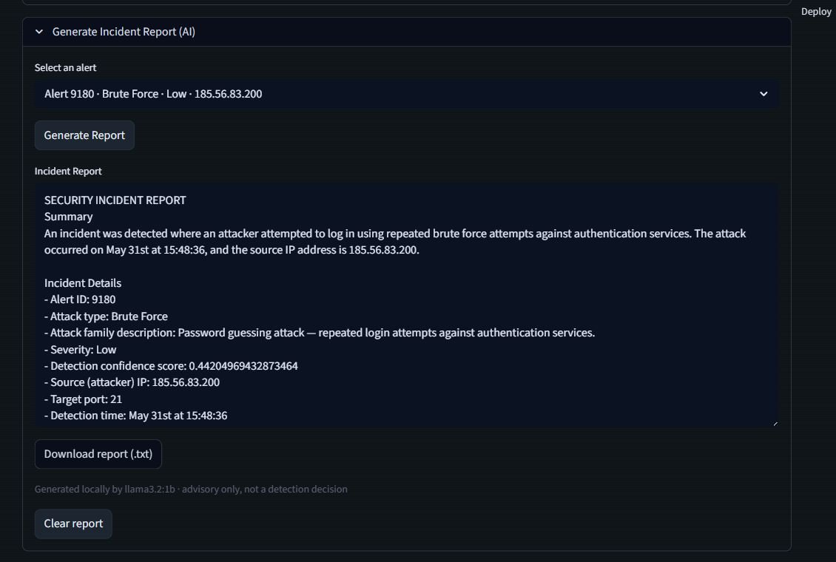
Figure 8.10 — AI incident report panel
This is the AI incident report panel. It generates a readable summary of a selected attack alert, which can be read on screen and downloaded.
Steps:
- Log in to the system (the local language model service should be running).
- Select an attack alert.
- Click Generate Report.
- Wait a few seconds for the report to be produced.
- Read the report on screen, or download it as a text file. (If the language model service is offline, the system shows an advisory notice and the rest of the system is unaffected.)

8.11 Logging Out
A user signs out to end their session securely.
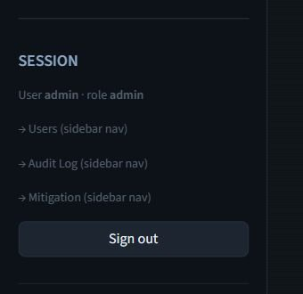
Figure 8.11 — Logout control
This is the sign-out control, which revokes the current session.
Steps:
- Click the sign-out button in the dashboard.
- Done — the session is revoked and the login screen is shown.

Chapter 9: Lessons Learnt and Future Work

9.1 Lessons Learnt
This project was developed in phases, and each phase produced lessons that shaped the final system.
Machine learning models reflect the data they were trained on. The most important technical lesson came from validating detection against real attacks. The model detects session-based attacks — slow HTTP denial-of-service, SSH brute force, and web scanning — reliably, because these produce multi-packet flows that resemble the training data. However, single-packet scan and flood tools produce very short, isolated flows that fall outside the training distribution, and these went undetected. This taught us that a model's real-world behavior cannot be assumed from its test-set accuracy alone; it must be validated against live traffic, and its boundaries must be understood and stated honestly rather than hidden.
Honest scoping is more valuable than over-promising. We deliberately kept the system to a single host, two roles, host-level mitigation, and human-in-the-loop approval, and we resisted adding technologies that would have inflated the scope without strengthening the core. This discipline kept the project deliverable and defendable: every design decision could be justified by a clear reason rather than by a wish to appear more advanced.
Security features must be designed in, not bolted on. Adding authentication, role-based access control, and an audit trail in Phase 2 showed how much these depend on careful design — password hashing, session handling, login lockout, and recording every privileged action all had to work together. Building the two-person rule into the mitigation workflow reinforced that a security control is only meaningful if it cannot be trivially bypassed, including by the person performing the action.
Real systems must handle failure gracefully. Several lessons came from things that did not work the first time: handling detections so that a database error never silently loses an alert, ensuring a firewall command that fails is recorded rather than hidden, and making the AI report degrade to a notice instead of breaking the system when the language model is unavailable. A feature is only finished when its failure path is handled, not just its success path.
Disciplined testing builds confidence. Maintaining an automated test suite that could be run in under a minute after every change meant that adding new features rarely broke existing ones, and that the final build could be verified objectively. This was far more reliable than manual checking and made the system's correctness something we could demonstrate rather than merely claim.

9.2 Future Work
The following enhancements are not part of the current project but are natural extensions that were designed-for or identified during development.

Detection of scan and flood attacks. The clearest gap is the inability to detect single-packet scan and flood traffic. Future work would extend the traffic aggregator with cross-flow correlation so that many short, related flows from one source can be recognised together as a scan or flood, bringing these attacks into detectable range.
Multi-machine deployment with endpoint agents. The current system monitors a single host. A future version would introduce lightweight endpoint agents that forward traffic features to a central analysis service, allowing a fleet of machines to be monitored from one console.
Optional automatic blocking for high-confidence detections. Mitigation is currently always human-approved by design. A future option could allow automatic blocking for very high-confidence detections, with appropriate safeguards, for environments that need an immediate response.
Encrypted-traffic detection. The current model works on flow-level statistics and was not validated against encrypted-channel attacks. Future work would investigate detection techniques suited to encrypted traffic.
Cloud and threat-intelligence integration. Although the system is deliberately offline, a future version could optionally integrate external threat-intelligence feeds to enrich detections, for deployments where internet access is acceptable.
Model retraining and drift monitoring. A future pipeline would support periodic retraining on new data and monitor for changes in traffic patterns over time, including the multi-class labelling behavior observed during live validation, so the model can be kept current.
Production-grade interface and reporting. The dashboard is intentionally simple. Future work could provide a more polished operator interface and richer reporting, including exporting incident reports as formatted PDF documents.
Hardening for third-party security software. During testing, third-party antivirus software was observed to interfere with firewall enforcement. Future work would harden the mitigation path to coexist with such software more reliably.
These extensions build on the foundation delivered in this project. The current system was designed deliberately as a working, auditable, single-host detection-and-mitigation tool, and each item above represents a considered next step rather than a gap left unaddressed.

References

Journal Articles
[1] A. L. Buczak and E. Guven, "A Survey of Data Mining and Machine Learning Methods for Cyber Security Intrusion Detection," IEEE Communications Surveys & Tutorials, vol. 18, no. 2, pp. 1153-1176, Second Quarter 2016, doi: 10.1109/COMST.2015.2494502.
[2] S. Vielberth, F. Bohm, I. Fichtinger, and G. Pernul, "Security Operations Center: A Systematic Study and Open Challenges," IEEE Access, vol. 8, pp. 227756-227779, 2020, doi: 10.1109/ACCESS.2020.3045514.
Conference Papers
[3] I. Sharafaldin, A. H. Lashkari, and A. A. Ghorbani, "Toward Generating a New Intrusion Detection Dataset and Intrusion Traffic Characterization," in Proceedings of the 4th International Conference on Information Systems Security and Privacy (ICISSP), Funchal, Portugal, 2018, pp. 108-116, doi: 10.5220/0006639801080116.
Online Documents / Technical Documentation
[4] The Npcap Project, "Npcap: Packet capture library for Windows." [Online]. Available: https://npcap.com. [Accessed: Jun. 1, 2026].
[5] Ollama, "Ollama: Run large language models locally." [Online]. Available: https://ollama.com. [Accessed: Jun. 1, 2026].
[6] Scikit-Learn Developers, "Scikit-Learn: Machine Learning in Python." [Online]. Available: https://scikit-learn.org. [Accessed: Jun. 1, 2026].
[7] FastAPI Documentation, "FastAPI: High Performance Web Framework for APIs." [Online]. Available: https://fastapi.tiangolo.com. [Accessed: Jun. 1, 2026].
[8] Streamlit Inc., "Streamlit: A faster way to build and share data apps." [Online]. Available: https://streamlit.io. [Accessed: Jun. 1, 2026].

Appendix

Appendix A — Dataset Description
The system is trained and evaluated using the CIC-IDS2017 dataset, which contains labeled network traffic representing both benign activity and multiple categories of cyberattacks, including denial-of-service, distributed denial-of-service, brute-force, port scanning, web attacks, and infiltration. For this project the dataset was preprocessed into a balanced training set of 418,481 flow records. Detection is performed in two stages: a binary stage that labels traffic as benign (0) or malicious (1), and a multi-class stage that assigns malicious traffic to one of eight families (Benign, Bot, Brute Force, DDoS, DoS, Infiltration, Port Scan, Web Attack). Preprocessing included data cleaning, class balancing, normalization, and mapping the dataset's columns onto a unified 50-feature schema.
Appendix B — Machine Learning Feature Set
The system uses a fixed set of 50 flow-based features extracted from network traffic. These include flow duration, forward and backward packet counts and lengths, inter-arrival-time statistics, TCP flag counts, source and destination ports, protocol, byte and packet rate features, window sizes, subflow features, and active/idle statistics. No IP address is used as a model input; IP addresses are stored only for forensic and mitigation purposes. The feature set was chosen to capture the statistical and behavioral characteristics of network flows while keeping classification efficient enough for near-real-time analysis.
Appendix C — Database and Alert Record Structure
All system data is stored in a local SQLite database consisting of ten tables: four detection tables (traffic_flow, detection_result, alert, mitigation_record), three authentication tables (user, session, audit_log), two mitigation tables (mitigation_request, mitigation_action), and one security table (login_attempts). Each detection is written as a single transaction that records the flow, its classification result, and — for malicious flows — an alert and a mitigation record. In addition, alerts are written to a backup CSV log whose fields are time, flow ID, score, and label, allowing historical detections to be reviewed and supporting investigation.
Appendix D — System Environment and Configuration
The system was developed and tested on a Windows host running Python 3.12. The backend API is served by Uvicorn on the local loopback interface, the dashboard runs on Streamlit and is presented in a native desktop window, and data is stored in a local SQLite database. Live packet capture requires the Npcap driver, and firewall mitigation requires the application to run with administrator privileges. Real-attack validation was performed using an isolated Kali Linux virtual machine on a host-only VMware network, with the attacker and the monitored host on the same private network and no connection to any external network. The optional AI incident-report feature uses a language model served locally by Ollama. The system requires no cloud services or external infrastructure and runs entirely offline.

